Semester: P1

## **Aalborg University Copenhagen**

Title: Android application – BarAlpha

Aalborg University Copenhagen  
Lautrupvang 1A, 2750 Ballerup, Denmark  
  
Secretary: Marianne Kiær Schwaner  
Phone: 9940 2471  
mks@staff.aau.dk

**Project period:** October – December

**Semester theme:** Android Application

**Supervisor(s):**

**Abstract:**

The main objective of this report is to discuss and describe the development of an Android application that addresses the problem of the lack of readily accessible information about student bars in Denmark.

In the development of this application (BarAlpha) we used the analysis of existing material, a survey completed by students, as well as brainstorming and other well-known methods.

In the process of development we managed to produce a working alpha version of the application as well as come up with ideas for further development features.

Karsten Vandrup

Morten Falch

**Project group no.:** 1

**Members:**

Andrei Tigau

Cem Turan

Christopher Wøhlk Pedersen

Ivan Vinogradrov

Klaus Klokmose Nielsen

Peter Sandbeck Nielsen

**Copies: 3**

**Pages: 74**

**Finished: 20-12-2011**

Copyright © 2011. This report and/or appended material may not be partly or completely published or copied without prior written approval from the authors. Neither may the contents be used for commercial purposes without this written approval.

**Student Signatures**

Andrei Tigau

Cem Turan

Christopher Wøhlk Pedersen

Ivan Vinogradrov

Klaus Klokmose Nielsen

Peter Sandbeck Nielsen

**Content list**

1 Introduction 5

1.2 Brief description of our application 6

2 Methodology 7

3 State of the art 8

4 Market analysis 18

5 Student survey 21

5.11 Survey conclusion 27

6 Designing an Android application 28

7 The Android platform 31

8 Design description 35

8.1 Ways of finding student bars and scenarios 35

8.12 Unimplemented features 42

9 Tools used in development 45

10 Future development 46

11 The design and development process 48

11.1 Analyzing the application – a design documentation 48

11.2 System definition 49

11.3 Requirements specification 49

11.4 The Technical Platform 50

11.5 Initialization 51

11.6 Model-component 51

11.8 Implementation - The Databases 53

12 Conclusion 56

13 Sources 57

14 Appendix 60

# Introduction

Nowadays, the majority of students are very preoccupied with the new technologies available in the communication and information technology fields, like computers, mobile phones and also in the development of Smartphone applications. So why develop an application for Android phones? Firstly, according to an article, in the last quarter of this year, Android represented 53% of Smartphone shipments, also supported by Gartner [0] — with approximately 60 million devices shipped worldwide. This shows a significant increase since last year when Android’s market share was only 25%, half of what it is today. In the same time, Apple’s market share dropped 2% from last year’s 17%. Although the overall quality of the applications found in the Apple App Store far exceeds the quality of the ones created for the Android Market, the later are in greater number[1]. An application’s usefulness can only be determined by the users, so with a higher number of apps to choose from, more of the users’ needs will be satisfied and that will encourage more developers to take advantage of the Android Market.

Also, from our own survey results, we noticed that there are a higher number of the students that own an Android Smartphone (47%), as opposed to 28% who use the iOS platform. Now that we know that Android could prove a profitable market, what functionalities should our application have? According to an older survey [2], location based applications go hand in hand with social networks. Our findings concerning social media applications also point towards an increased use among students and what is more, there is a trend involving Danish students to go out in the city during weekends and visit multiple bars in a single night.

We tried to implement these two features into our application that seem like they could show an improvement and market growth [3] in the following months, and these are; the Geolocation represented by Google Maps and social networks represented by Facebook.

Problem formulation

*“It is a problem that there currently is no convenient way for university students to locate university bars and find out whether they are open/closed, information about events, restricted to certain students and what the prices are.”*

Students tend to visit student bars often during the weekends and sometimes they find out too late that the bar is closing, or they can not discover in advance if they are even allowed in some other student bar, because of age or other specific restrictions, or it might just be the case when they are looking for a new place to spend time with friends or make new ones.

We thought that we could resolve the issues occurring in the above-mentioned situations through the development of our application called BarAlpha.

## Brief description of our application

What our application (see [Example 1.1]) does is to help the users locate student bars, by displaying them in a built-in map, also giving directions on how to reach them and information about the bars like; prices and opening hours. At the same time, it has a social component represented by the Facebook sign in. Button (5) allows the user to use his/her Facebook account and check-in at a location bars, and by doing this, he/she can let friends know about his/her whereabouts if they can see his/her Facebook profile, the function being of cause optional.

The application was designed in this way because we wanted to offer to the user a good user experience, making it simple and easy to use, but at the same time implementing as many functions as the time allowed us. For example, the main round button (1) sends the user to the map view and searches for the nearest student bars, and can from there ask for information and directions to a specific student bar.

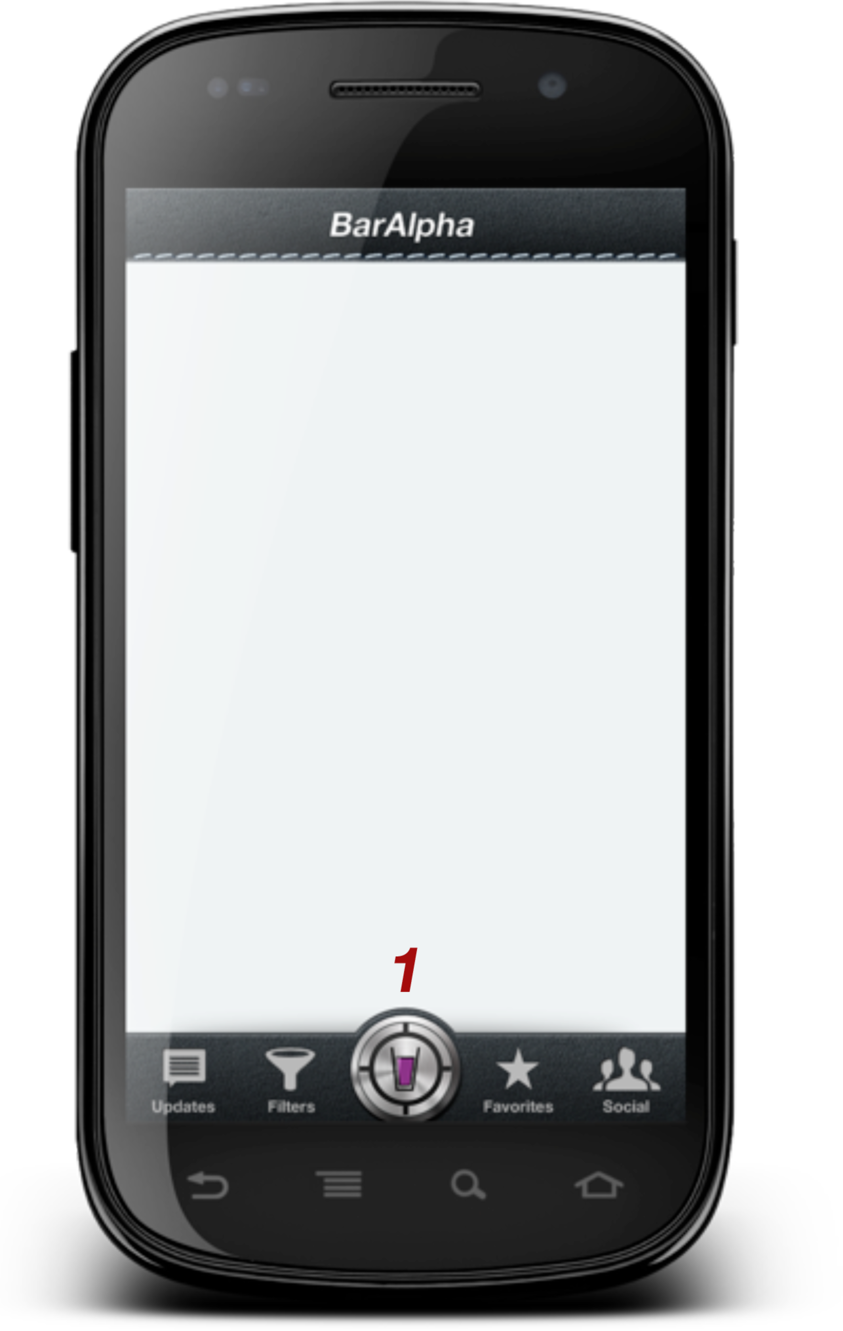

[Example 1.1]

# Methodology

Brainstorming

Brainstorming is when one spills his mind and does not reject any of the ideas. After all the ideas are on the table on comments and then selects the best of them. We used this method in most of the early design stages. The ideas were later confirmed, dropped or changed because of further analysis.

Survey analysis (quantitative)

Considering that we are making an application for mobile devices it is a good idea to know if the target group finds our application useful. Therefore we decided to make a survey containing questions about habits concerning student bars and drinking alcohol. We sent the survey out via Facebook both using a group created for the Rus-course and also posting it on our status for all of our friends to see. The reason we posted the survey here is because the majority of our target group is using Facebook as social media. The idea was to figure out exactly what features our application should contain and what was not important.

We have used statistics to show how applications are distributed and downloaded via the Internet and it gives us an insight about how we should/should distribute our application.

Scenarios (qualitative)

We have written two scenarios to give an insight in how our application is supposed to help students in certain situations. Of cause this is what one would describe as “soft data”, but we use it to give a description on how a student could benefit from using the application.

Literature reading (qualitative)

As a part of the research process we used literature to analyze different information and issues. We have used processed material as books and journals and we used the Internet to search for other sources - while keeping in mind that it is important to be critical to any information found on the Internet as it is not always scientific material. This means that we used empirical material and generated it into theory to accomplish a general description of how we would solve the issue we stated in the problem formulation.

Software development methodology

When developing the application we used the Waterfall method. It involves using time to make the specifications to the product first, and then move on to the actual programming. We used this method throughout the development of the application, because we did not know about the downsides to this method – which was that the development of the application took longer time than first approximated and it was hard to keep track of how long time a specific part took to develop.

# State of the art

When developing a product or in our case an Android application it is important to look at what others have done and which tools, technologies and strategies are used. By doing so we can ensure we gain a broad overview of the market, competing products, and effectively pick out the best parts and combine them into a product that covers holes in functionality, usability and markets not done by our competitors. Furthermore this will allow us to develop an application that meets certain standards and criteria previously set out by developers and the users.

The first obvious place to look is the Android marketplace as this is the main distribution channel for Android applications. A search in the Android marketplace reveals 12 applications that have the functionality of locating bars/pubs. Out of these, 3 were incompatible with our fairly new Android phones (Google Nexus S), and 2 were not free. This leaves out 7 applications we can freely analyze.

As none of them list student bars the following analysis will be of a pure technical point of view, looking at the implementations and features of the apps. This section will show a written analysis of the various applications and a visual analysis is found in the appendix (See table 1 in the Appendix).

[****Bar Finder****](https://market.android.com/details?id=com.uknowapps.android.barfinder&feature=search_result&pli=1) ****- by**** [****UkNowApps****](http://uknowapps.blogspot.com/)

This app (See [Example 3.1]) offers the user the possibility to define a start point and a range and offers basic sorting options (name, distance) of the results.

When and only when in the search results view it is possible to plot the results on a map. When pressed on a specific bar - the information of the bar is revealed which is fairly restricted to only having a phone number and address and the possibility to dial the place. Furthermore it is possible to favorite places for easy access in the future.

Map data:

* **Google Maps:** The map layer is provided by Google but is only accessible when the user wants the specific bar located on a map from within the specific bar page. Therefore it does not show the bars in a map view, which is a feature of most of the apps tested.

Bar data:

* **Google Maps:** is used for locating Bars, Karaoke Bars, Pubs and Wine Bars. The results are very mixed due to the fact that the App searches for the above keywords instead of filtering out the results by searching for specific categories, also known as a type, such as “Bar”. The current implementation results in an app suggesting places that have one of the keywords in their description or name. We are therefore met by a list where more than 50% of the results are places other than what we are looking for.

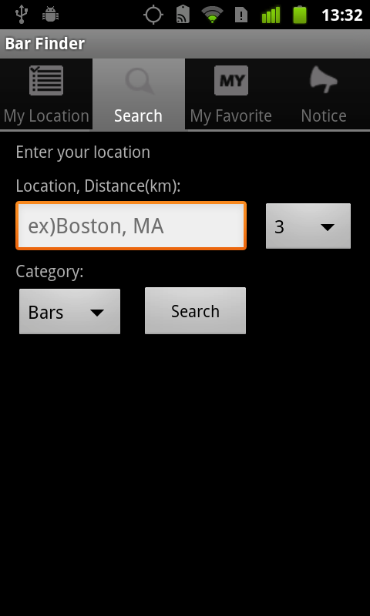 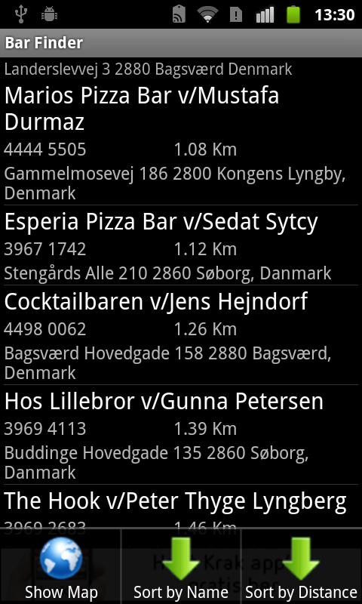 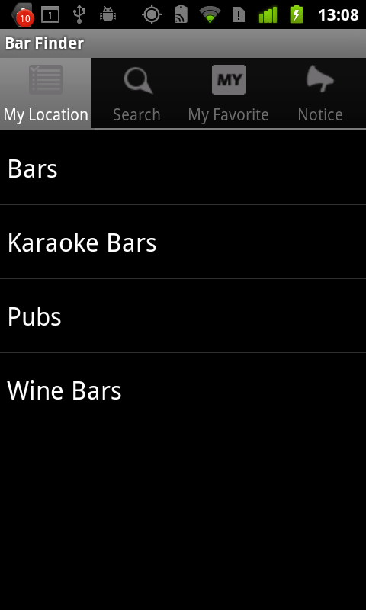

[Example 3.1]

[****BarFinder****](https://market.android.com/details?id=net.beeroclock.dbeer&feature=search_result) ****- by**** [****Karl Palsson****](http://dbeer.ekta.is/)

This App (See [Example 3.2]) uses a somewhat similar approach when searching for bars as the previous app. This results in irrelevant bar suggestions as in the case above case. BarFinder offers the user an easier approach in searching for bars as this is done the second the app is launched. In many ways this app is a stripped down version of the previous, as it does not offer searching for bars from a specific start point and within a range. Furthermore it seems that the results shown are restricted to the nearest bars in a range of 6 kilometres. But it should be noted that BarFinder offers added functionality such as filtering out cafés from the search result, which gives a more accurate representation in what the user wants to see in the search results. But due to the distance restriction only 9 bars/pubs/bodegas are shown.

Notable features:

* **Prices -** Another unique feature of this app is the possibility for users to add prices to the specific place. A feature which in many cases could offer problems such as incorrect data, but the developer has put in one feature to lower this as you have to be within a defined radius of the place to add the price.
* **Favorite drink –** Allows the user to select a favorite drink, which will set prices for the default drink and show these in the list view. But due to the actual lack of user submitted prices this feature is rendered useless.

Map data:

* **Google Maps:** provides the map overlay, which is used in a similar fashion as in the previous app. This possesses the same limitations as previously described.

Bar Data:

* Bar data is similarly provided by Google Maps as in the previous app.

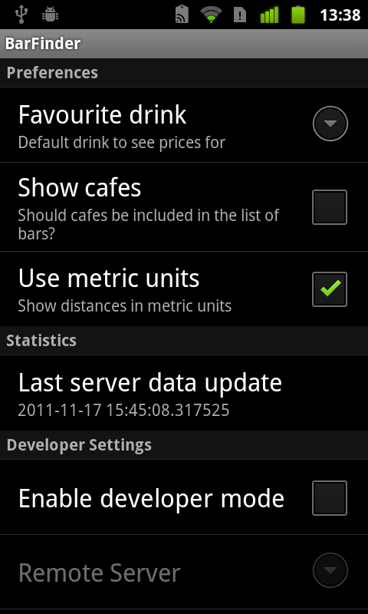 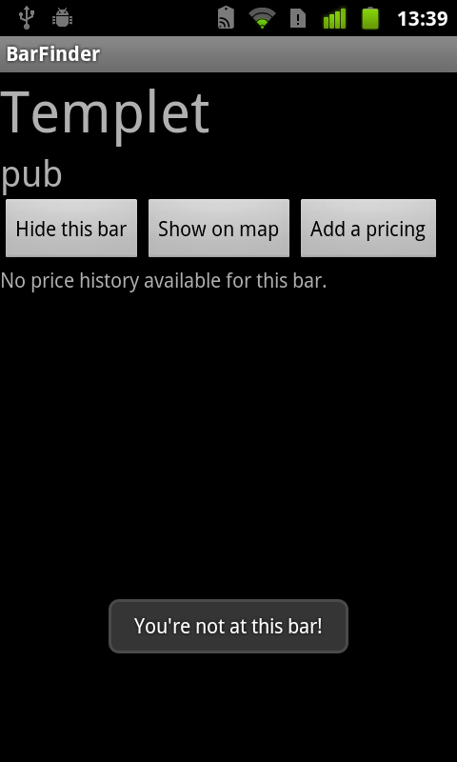 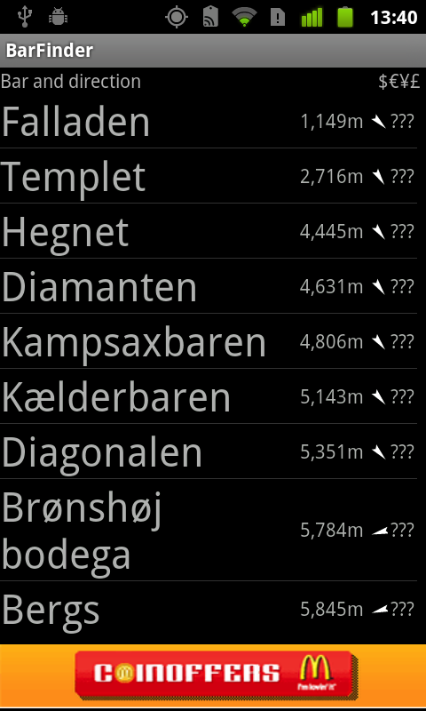

[Example 3.2]

[****Beer Finder****](https://market.android.com/details?id=com.finerdesign.beerfinder&feature=search_result) ****- by**** [****Finer Design****](https://market.android.com/developer?pub=Finer+Design)

The initial launch of the application failed, as we seemed to be stuck with the following message, “Grabbing your location…” for 5 minutes. Then as suggested by the app we went outside and we did manage to proceed after a minute (See [Example 3.3]).

Notable features:

* **Directional needle** - Beer Finder takes a unique approach with the way of navigation as this is done by following the direction the compass needle and by an indicator in the top showing how far you are from the place. Due to this approach it is not possible to define another starting point than the current location.

Map data:

* Beer Finder does not display the bar(s) on a map as it acts as a tool to navigate to a bar rather than listing and comparing bars.

Bar data:

* **Google Maps/Places –** is used to retrieve the name and addresses of the bars. The developer of this app has acknowledged the problem with irrelevant search results and solved this by either searching for the type of the place or developed a search filter.

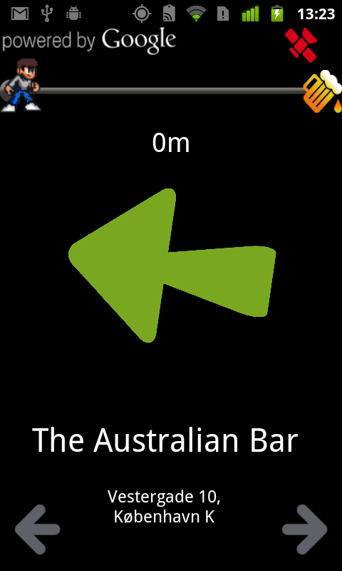 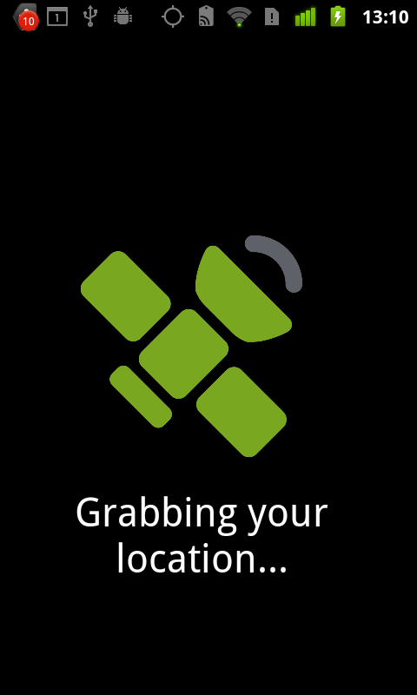 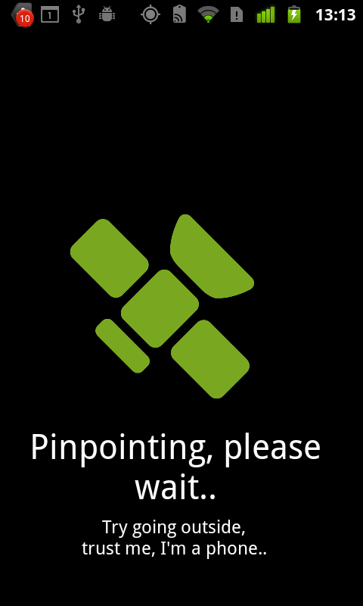

[Example 3.3]

[****Find Pubs & Bars****](https://market.android.com/details?id=com.elbatrop.pubs&feature=search_result) ****- by**** [****Elbatrop Ltd.****](http://www.google.com/url?q=http%3A%2F%2Felbatrop.com%2F&sa=D&sntz=1&usg=AFQjCNGZnUe3qX6xa-TKRcL8nMwTtFNH9Q)

Compared to the other apps Find Pubs & Bars offers a hybrid view for displaying results. By combining the list and map view the user is able to see in kilometers and visually on the map how far away the place is from the current location. Unfortunately the placement of an ad takes up ⅓ of the list view, which limits it to show only two results at a time (See [Example 3.4]).

Notable features:

* **Add / edit bar –** is a feature which allows the user to add and edit bars. This includes the bars’ name, address and opening hours.
* **Open in Google Maps, Street View, Get direction –** These features allow the user to open the location on the Google maps application on the phone and make use of the immense and useful features provided here.

Map Data:

* **Google Maps** – Is used as the actual representation of the map layer whereas OpenStreetMap acts as an overlay with the actual bar locations.

Bar Data:

* **OpenStreetMap** - The bar data is in this case not provided by Google Maps, but OpenStreetMap, which is a free editable map of the whole world. By searching for a type tag such as “bar” we are presented with relevant search results.

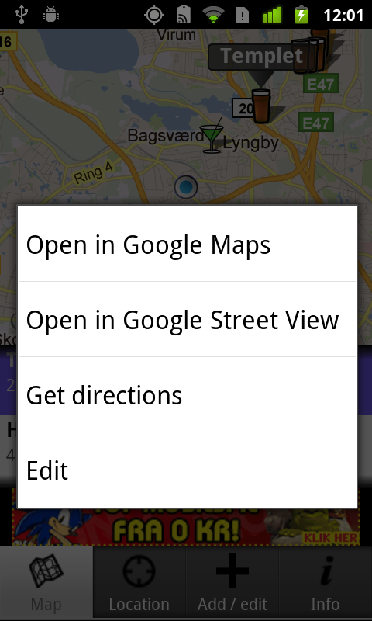 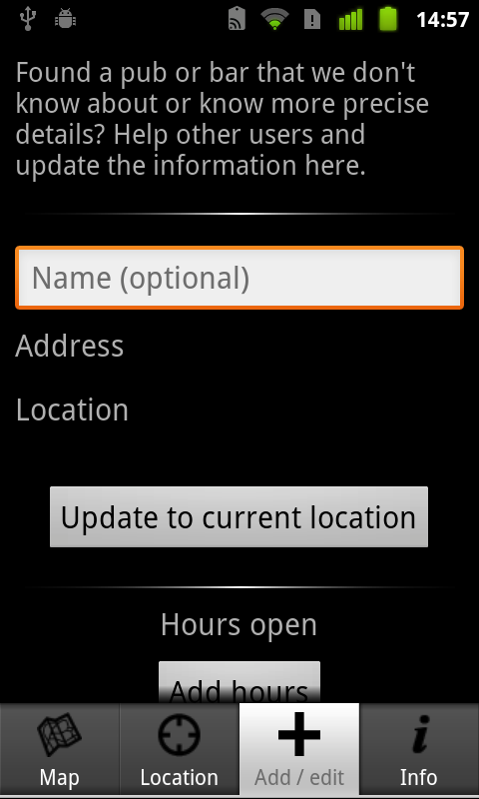 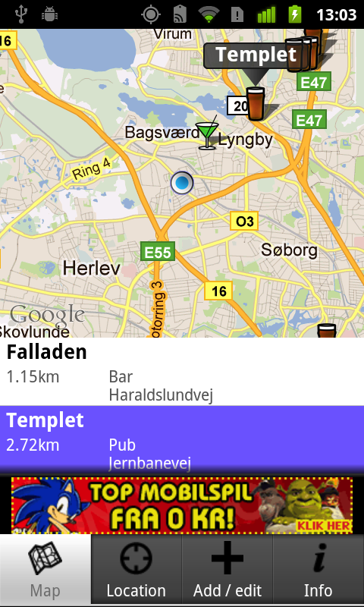

[Example 3.4]

[****DrinkedIn - Bar Finder****](https://market.android.com/details?id=com.DrinkedIn.BarFinder&feature=search_result#?t=W251bGwsMSwxLDEsImNvbS5Ecmlua2VkSW4uQmFyRmluZGVyIl0.) ****- by**** [****DrinkedIn****](http://drinkedin.net/)

Compared to the first three apps DrinkedIn collects the bar data by themselves and with the help of the community. They promote themselves as the world’s largest social network for people who drink alcohol and they encourage their users to leave reviews, ratings, photos and comments about the places they visit.

The mobile app itself(See [Example 3.5]) acts as a tool to locate the bars from your current location and furthermore it also acts as a mobile portal into the information submitted on the website (See [Example 3.5]

). Even though they have an impressive amount of bars in their database - the app is quite unstable and tends to crash. While being unable to locate any bars on the android version we decided to try out the iOS version for the iPhone. We were surprised to find that the iOS version of the app required that the user had to login to use the application. Something there was no evidence of on the Android version. When logging in a whole new aspect of the application is revealed, the social network. This implementation is in many ways similar to Facebook, but it should be noted that it can in no way replace Facebook, but supplement it as a portal for people who find Facebook lacking in the drinking and nightlife community.

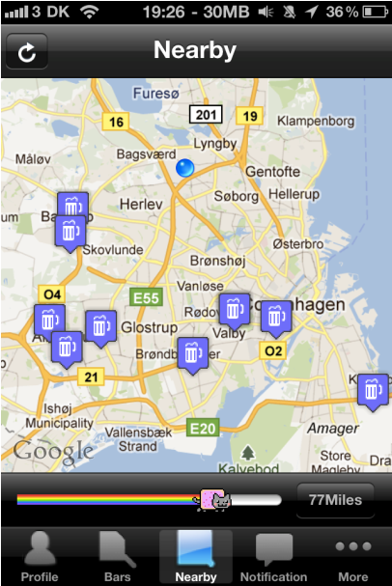 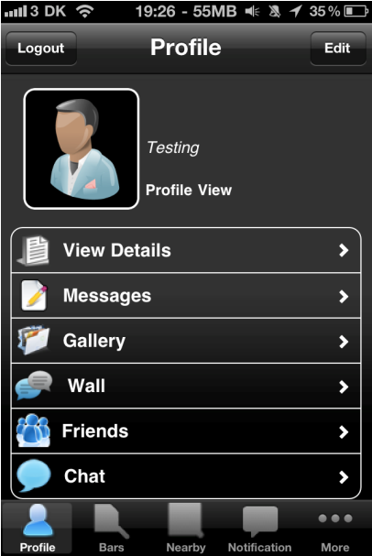 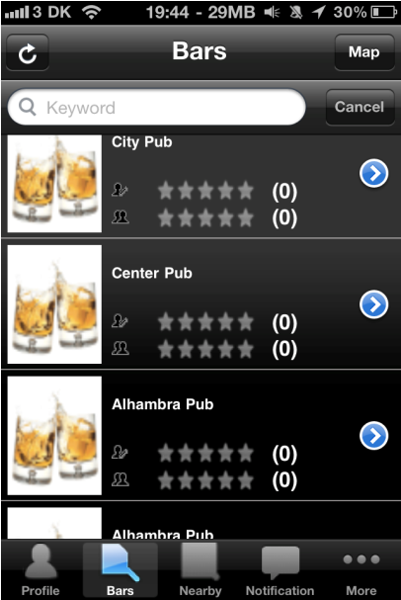

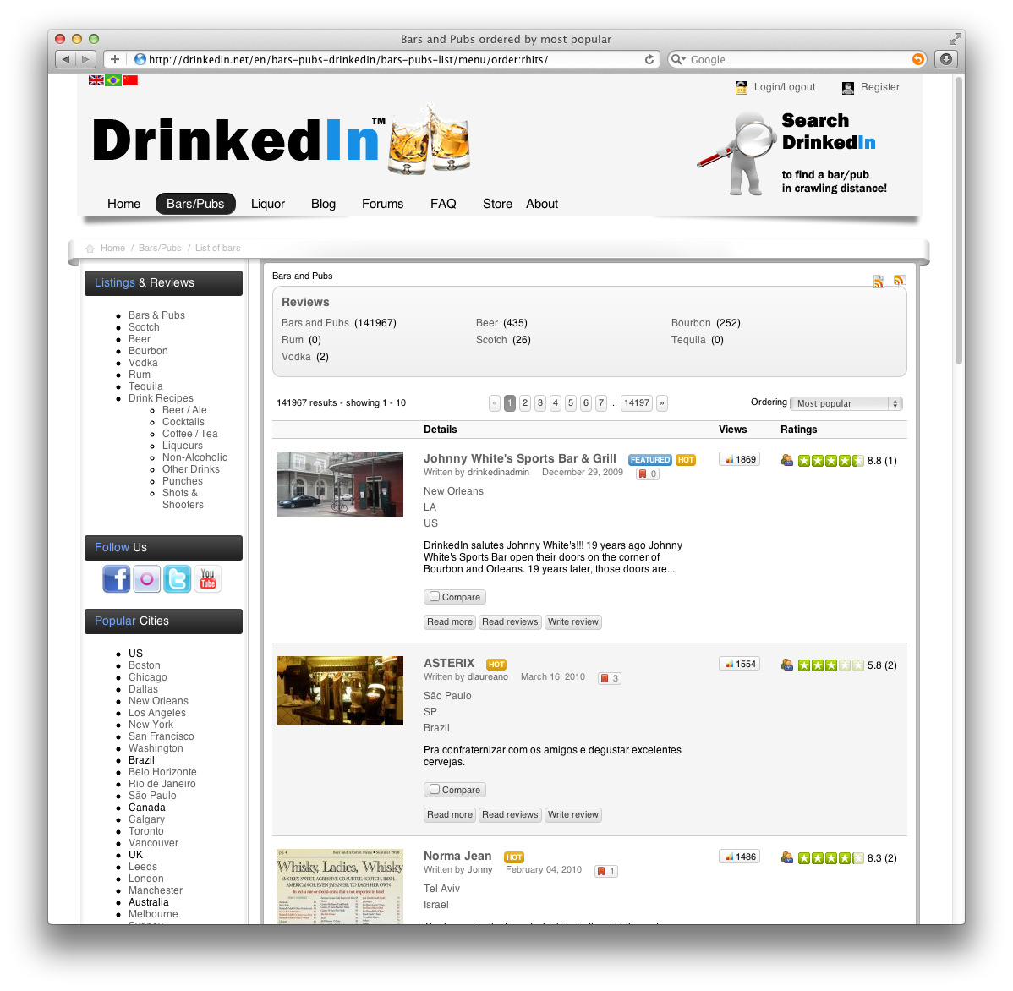[Example 3.5]

[Example 3.6]

On their website they promote the mobile app as following: *“The DrinkedIn Mobile application is the best way to find and review bars, upload photos of you & your friends at your favorite place and more.”,* when in reality most of these features are only available on the iPhone.

****Not in Denmark****

The following three applications have the common remark that they are made for a specific geographical market other than Denmark. Hence they are rendered completely useless here in Denmark; they do offer some additional functionality not seen in the previous apps, which is worth pointing out.

[****Your Heineken Passport - NZ****](https://market.android.com/details?id=com.heineken.hostnation&feature=search_result#?t=W251bGwsMSwxLDEsImNvbS5oZWluZWtlbi5ob3N0bmF0aW9uIl0.) ****- by**** [****Image Centre Ltd****](http://www.image-centre.com/)****.****

This App (See [Example 3.7]) is created as a tool for Rugby fans to gather around at bars together with fans of the same team and of course in bars that serve Heineken beer. There are no sorting options, prices, etc. as the main priority of this app is to help the user find out where the different groups of fans meet up. This is done by selecting a team at the initial launch of the app.

Notable features:

* **Check-in** - Your Heineken Passport offers the unique option of checking in, at the different bars. By checking in the users/fans earn bottle caps, where 5 bottle caps equals a ticket in the drawing of “tickets to the RWC 2011 Grand final”.
* **Call a cab** - Another unique feature is the e-taxi service, which presents the name and number of nearby taxi services that safely can get the user home when the day is over.

Map data:

* **Google Maps:** provides the map overlay.
* **Bar Data:** is provided by presumably Heineken in cooperation with the bar owners.

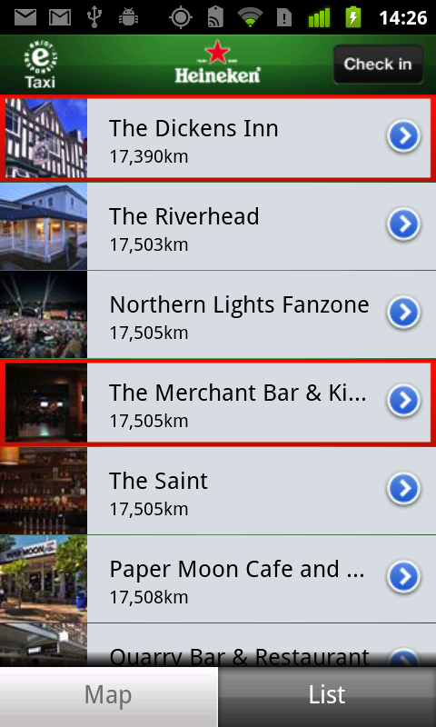 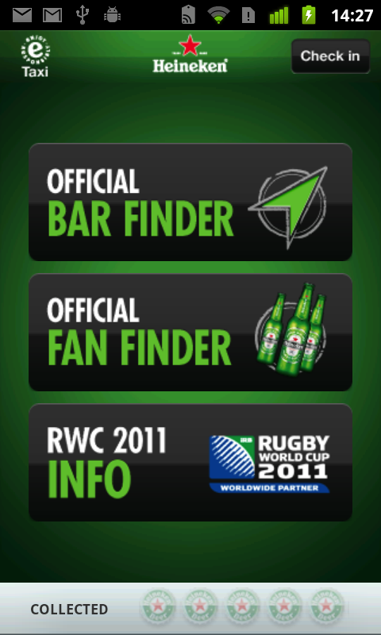 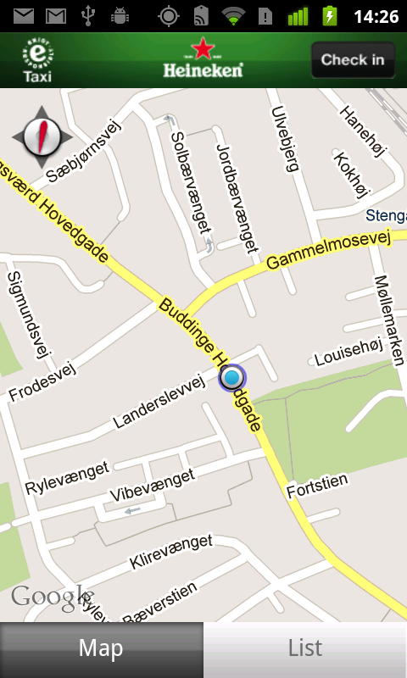

[Example 3.7]

[****DrinkOwl****](https://market.android.com/details?id=com.drinkowl) ****- by**** [****Great Owl Technologies, Inc.****](http://www.drinkowl.com/)

DrinkOwl (See [Example 3.8]) provides a quick overview of nearby bars in a map or list view. The map view provides an additional layer displaying happy hour deals from each bar. Furthermore it provides the user with not only the address but also prices, opening hours, events, website URL and discount coupons.

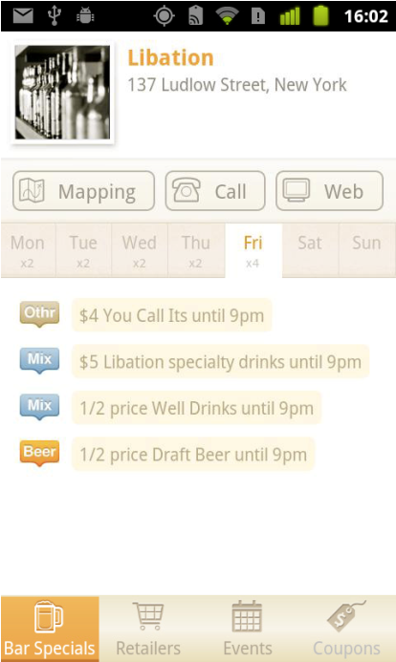 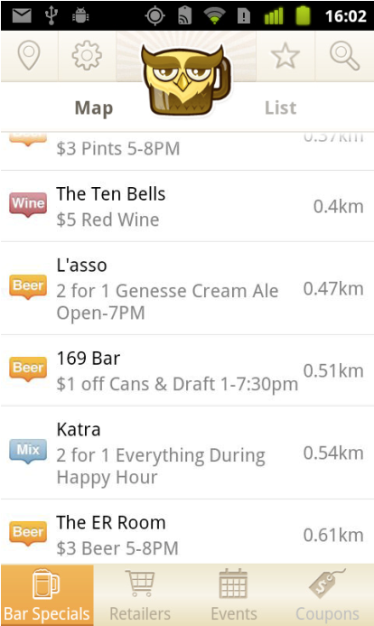 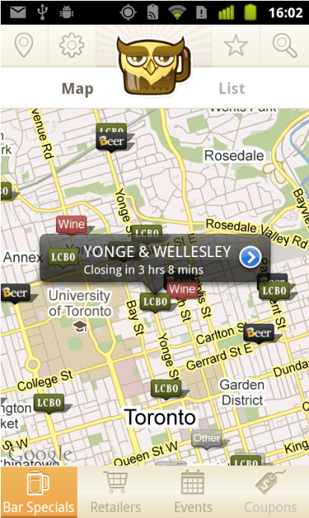

[Example 3.8]

Notable features:

* **Closing in –** Shows the user on the map view when the bar is closing.
* **Bar Specials –** Offers a view in the map and the list based upon Bar specials sorted by distance.
* **Events & Coupons –** Is features only available for certain cities thus it did not allow us to test these features.
* **Drink filter –** allows the user to choose which kind of drinks should be shown on the map and list view.

Map data:

* **Google Maps:** Similar to the previous apps, the map layer is provided by Google.
* **Bar Data:** Whereas the actual bar data, including location, address, opening hours, happy hour prices are submitted by the bar owner(s) from the DrinkOwl website (See [Example 3.9]).

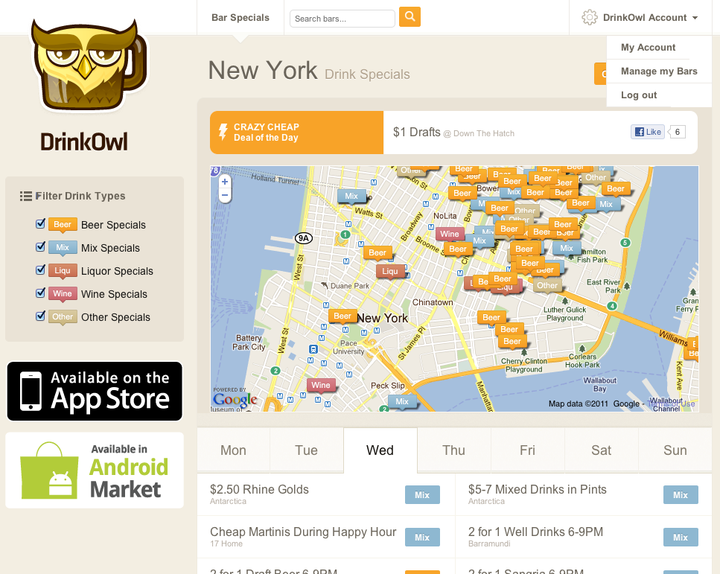

[Example 3.9]

Besides acting as the main interface for the bar administrators to manage their bars, it also acts as an alternative view for the user for finding a place with suitable prices.

****Overall impression****

****DrinkedIn****

The missing features in the Android application in combination with our general experience with the whole platform(website and mobile app) makes us doubt the legitimacy of the individual(s) behind this app as we find the overall design and experience to be lacking and not that well executed.

We do not see DrinkedIn as a serious competitor due to their current implementation and inconsistency between their Android application and iOS application. Furthermore we think that providing users with a secondary social networking site does not benefit the user as much as if it was implemented in the dominant social networking site, Facebook.

****DrinkOwl****

This is possibly the best overall application we have tested. Compared to the other apps, we find the design of DrinkOwl to be far superior in terms of usability and overall aesthetics. We see DrinkOwl as the work of a serious company with the user and their business partners in mind and as a serious competitor currently speaking and even more when they decide to roll out globally, which their recent inclusion of London could indicate. Where they geographically operate it seems that they act as a service that most bars use to promote their prices, and attract customers.

****Your Heineken Passport****

Over all we think that this application is well executed and fills the assumed needs of an all-in-one “passport” for rugby fans in New Zealand.

****And the rest****

In many ways the remaining apps do not offer anything different from the Google Maps/Places app found on multiple platforms. They basically render the results from a Google Maps search in their own way. They have an overall tendency of being quite lacking in terms of features, design and information about the bars.

And yet they are within the most downloaded, with Bar Finder having 100.000-500.000 downloads compared to DrinkOwl which has a mere 5.000-10.000 downloads. This might be due to the generic name of the app, “Bar Finder”, and that it might have been on the Android Market for a longer period. Other indications could also be that Bar Finder reaches out to more people due to their service being deployed worldwide thanks to Google Maps.

# Market analysis

General trends

The current market holds several applications that all utilize the simpler functionalities of the Android device, such as the Google services included in the OS. However, none of the apps have acquired any popularity compared to other specialized apps. In general, the number of downloads for typical bar finder apps is in the tens of thousands, with a few apps being in definite lead with hundreds of thousands [5]. The obvious trend is the utilizing of Google maps to look for desired establishment, as well as utilizing other methods that are available to users themselves directly. Most likely reason for such business behavior is that it saves development time as well as resources and allows a more easily coded and stable piece of software.

The business models of developers are usually fairly similar and they often focus on developing applications for only one or two prominent platforms, in this case, the mobile version [6].

Another thing worth noting here is the fact that most developers do not charge a fee for the download of their app in this or any other categories. This can be seen upon the examination of the existing similar applications as well as the market in general, with almost two thirds of all apps being free. [Chart 4.1] [7] demonstrates the overall distribution of paid and free apps in the current market.

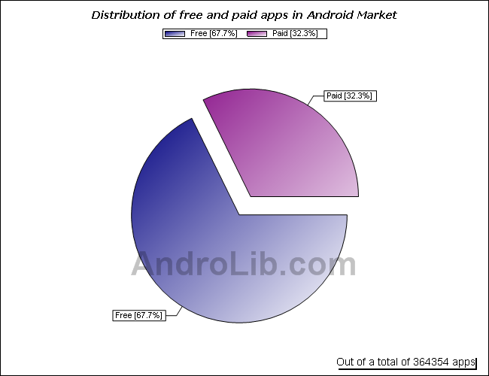

[Chart 4.1] [7]

Another user expectation is, based upon available data, that the suitable application is free. The preference for free mobile applications for Android is a definite trend, which can clearly be seen on the [Chart 4.2] [8]

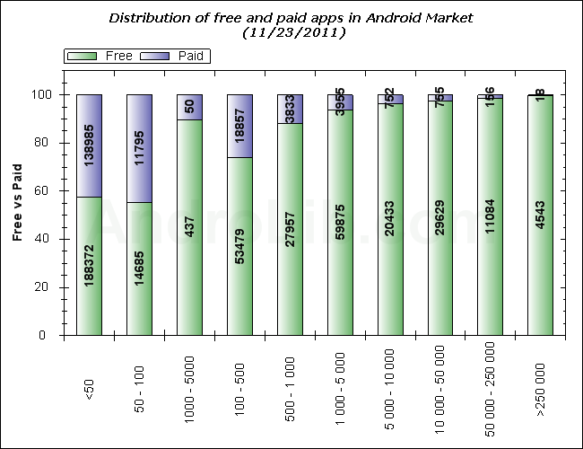

[Chart 4.2] [8]

Emerging trends

The main trend in mobile application and many other areas of software development is increased socialization of the media [9]. Thus, we can expect the users to expect some, at least partial integration of social networking and other services into the overall application and services therein.

Another trend is of course the merging and dissolving of other companies, so we can expect changes to competition in the coming years. This can be called an emerging trend because only recent financial and economic crisis caused its noticeable acceleration. This change will undoubtedly become more noticeable as time passes, as the economic crisis caused the smaller companies to merge or get sold in order to survive financially. This is demonstrated in the research done by the firm AlixPartners [10] in 2011. The debt of the high-tech companies that is causing them to find solutions in buyouts and merging is shown in the Chart 2.3.

Certainly, a role will be played by the progressing development of technology and the merging of it into the real life, which is happening with an increasing pace and can therefore be also called an emerging new trend. This can be demonstrated on the example of granted and filed patents per year for the last few decades. That data can be found openly on the World Intellectual Property Organization [5] web page. Most notable is the sharp increase in filed patents over the last 3 years. This will potentially increase competition exponentially as well as force us to employ more resources for keeping the app up-to date.

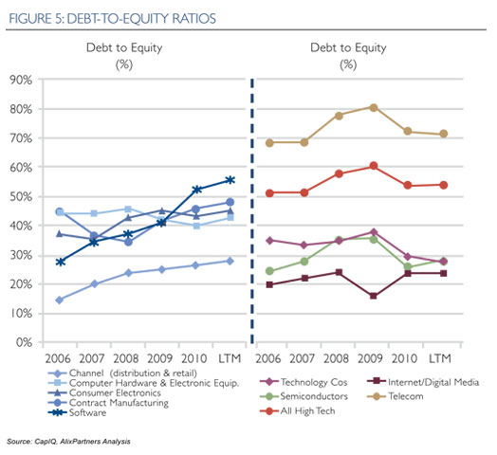

**[Chart 4.3] [11]**

Potential market(s)

The main market we will initially be aiming at is the one that is located in Denmark. The initial geographic expansion would therefore be aimed at expanding to the mainland Denmark, covering the most major cities first. The expansion of the market will cover the app market that deals with alcohol, as well as event and establishment location, striving to take a share out of those markets.

Later expansion would be aimed to cover mainland Europe and assume the dominant role on the app market, as well as severely improving services, adding new ones and increasing staff numbers.

Sub conclusion

Based on the above analysis we can conclude that we will benefit from employing a number of strategies. First of all, we will aim to make our application completely free and minimize the effect of compensation methods on the consumer’s experience. This will allow us to appeal to a much larger audience of consumers, than the competitors that are charging a fee for the use of their product. We will hope to differ from the free app providers by higher functionality and overall quality.

We can see by taking a look at the analysis that the user expects an application that allows for minimum personal effort and involvement, as well as being precise and effective at the specific task it was designed for. Other common modifiers include price, popularity, ratings as well as personal preference that are individual in each case.

Second of all, we will try to bring the app into profitability and sell it, instead of forming a company in spite of the high volatility of the current market as well as our inability to operate as a company at the moment. We will not aim for profit as our immediate goal. We would prefer to see our solutions perform well and then build upon the experience.

Third of all, we will attempt to implement the most innovative solutions as well as implement them in the most rational way to soften the speed with which the application becomes dated. The programming solution we are planning to employ is, in fact, relatively new to the market and severely more intricate than the ones that are used by the potential competitors at the present time. We will also update the application on a regular basis.

Finally, we will aim to use social media and other Internet-based social outlets to complement our application and the process of its development. We aim to employ several additional services as a part of our application, which will in turn provide us with more user feedback and more potential development paths. We intend to involve as many parties as possible in the development and maintenance of the application. That will serve to cater to the largest market as well as keep track of user data.

# Student survey

While looking into our market of primarily university students we figured out that our group would not be the perfect stereotype of university students. The purpose of creating a survey was therefore to take a tour inside and paint a more general image of how habits concerning student leisure time as well as use of smart-phones look like. With a deeper understanding of the proposed user requirements and needs distilled from the survey we believe that we can more effectively determine which of our own ideas about a smart-phone application would be the most important ones. We received a total of 78 answers in our survey, which we wouldn’t describe as scientific, but an attempt in getting a broader perspective from our market.

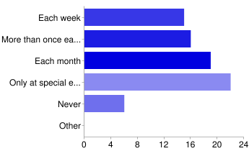

[Illustration of question #1]

Bar habits

When looking at question 1(see illustration of question #1), it indicates that 92% students go to bars at some point in their life and only 8% do not. Question 2 asks if students go to regular bars and 95% do. And it is interesting to see that 38% go to these bars each month, when you see that only 21% do that in student bars. We did not ask why, but an idea would be that students from universities have friends who do not study at a university. So that might be why they go to regular bars more than student bars. When looking at the answers from question 4 we can conclude that the majority go to bars with friends from outside campus or people they know from their own university. When students want to go to a new bar they would mostly ask their friends for information[1] and 12% would use a search engine or a university web page. When looking at the answers to question 8 it seems like the reputation is not the main concern when visiting a student bar. Again it seems that their main concern is if they are with their friends when looking at answers to question 4 and 5.

At Aalborg University CPH in Ballerup there is one bar at the university and one in another university across the road. This could indicate that these students would attend one or two bars regularly. 73%[2] of the students who answered the survey had one or two student bars that they visit routinely and some do not have any routines (15%) while others (12%) have 3 or more bars that they visit routinely. In order to get students to use student bars rather than regular bars it is our idea that a smart-phone application would make students use other student bars and thereby not meet the same people they always do when visiting their own student bar. It seems like there is a market for students who are not already visiting different student bars.

Drinking habits

At a student bar one can often buy a variety of drinks, beers etc. And we asked the students what they are most fond of drinking when visiting a student bar. Most students drink beer (83%), second they drink shots (38%), third they drink long drinks (26%) and finally they drink non-alcoholic drinks (9%). To sum this up – the most importing drinks to show prices of in an advertisement or an application would be beer, shot and long drink prices, because prices are important to students (see illustration of question #7). There are probably a long list of names and prices for long drinks, so it would be nearly impossible to show them all in an application all at one time. Therefore we believe that these prices should be excluded in our application because we want to show the users direct and correct information when they use our application.

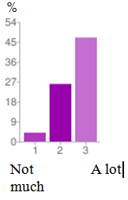  
[Illustration of question #7]

Opening hours

78% feel that opening hours affect in their choice of student bars[3]. It could be possible that these 78% would like a convenient way to find out when a bar opens/closes. Half (54%) of the students asked have had an experience, where their choice of student bar was affected by not knowing whether the bar was open/closed[4]. So maybe the ones who answered that they had the experience of not knowing about opening hours where it did NOT affect their choice in fact did not have the experience or else it did not have any effect on their choice. Looking back – this question could have been written more clear-cut so we would have a more accurate answer which we could analyze.

Privacy concerns

We were somewhat curious if students were concerned about the privacy issues when it comes to using social media to let others know where you are. We asked students if they wanted to let their friends know when they are at a bar and similarly if they wanted to know where their friends were. Of course this could be possible if one knows a friend’s cell phone number, but then one would have to wait for a response via text messaging or they would have to make a phone call. 63%[5] would like to let their friends know when they are at a bar and to know when and where their friends are. One student answers “Not always. Sometimes it is good. But sometimes I don't want to reveal my location.”[6] We believe that one can be in a situation where it is not smart to let friends know if one is at a specific location if they have issues with a friend. This answer is actually a fine example that students are concerned with possible issues conflicting with their privacy. When first starting this project, we talked about that the application should make it possible to tell friends if one was at a student bar. When analyzing these results it is quite obvious that this option should be controllable by the user. So if they did not want to check in at a student bar – they could disable the function.

Crowdedness

We asked the students if they were concerned about crowdedness when visiting a student bar. 51% answered between “not much” and “a lot”, which indicates that students are not completely ignorant to the fact that student bars are sometimes really crowded. We asked this question because we thought future development and the issue of crowdedness could be a future feature in the application. A student would be able to see if the student bar he or she was planning on going to was crowded or not. It does not seem to be a service that is really important to students because the majority of answers say that it does not concern them a lot.

Number of smart-phones among students

One of our first concerns was whether the students could potentially use our application at all. Therefore we found it fitting to ask whether they own a smart-phone, to which 74 % responded positively. It would therefore be fitting to conclude that the majority of students are familiar with the use of mobile applications, as well as the fact that a portion of the majority is using Android. The latter would be the market we are aiming at. Out of the leftover 25%, 10% expressed the desire to own a smart-phone at some point, further reaffirming the assumption that there is an expanding market for our product, as well as the overall popularity of mobile platforms among students in general.

Phone model

Of great interest was also the question of the comparative popularity of different mobile platforms among students. Here, the results were fairly favorable, as 42% responded that they were in the possession of an Android smart-phone, a clear majority among the respondents (see illustration of question #14). This would mean that we are in a position of benefit when compared to competing apps on other mobile platforms, as well as the fact that our market is sufficiently wide for this type of product. An interesting fact was that the remaining options were almost evenly divided with iPhones having 29 and other platforms 28 percent (a difference of 1 person). Combined with the previously stated number of individuals wanting a smart-phone, we could expect the majority of them to choose Android over iOS.

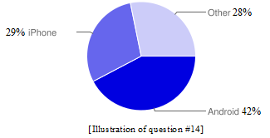

Use of 3rd party apps

When we inquired about the frequency of use of third party applications by students, the majority of respondents admitted using those daily, constituting 59% of all responses. Conservatively speaking, this definitely means that this application has no popularity-related disadvantages compared to the first party produced software. In fact, it would very likely be preferred for the specific task it performs.

The number of people who admitted using third party software once a week is 12%, which is fairly small compared to the number of those who use them frequently. Still, we can combine those two groups and get an impressive 71% of third party app users, which speaks optimistically in favor of application development. Another 4% admitted to never using third party applications. Finally, 25% did not respond, most likely not understanding the question or part of it or simply not being in the possession of a smart-phone.

Popularity of mobile applications by category

One of our questions encompassed the frequency of use and general popularity of mobile applications. We divided third party apps into four categories in our survey and asked the survey participants to rate the importance of each category from 1 to 5, 5 being the highest rating.

Lifestyle apps

The first option was about the lifestyle apps, or utility apps that are meant to make everyday tasks easier for the user. Most notable in this category was the fact that for the most part (29%) were deemed unimportant by the questioned audience, with the second most popular rating being 4 (15%), meaning fairly important. The three other answers ranged from 8 to 12 percent, with the rating of 5 being the least popular. The obvious conclusion from all this is the fact that lifestyle apps are fairly unpopular among students. Another thing that tells us this is that a fairly large (27%) number of respondents chose to ignore the question entirely, although this could also be attributed to the percentage now owning a smart-phone.

Navigation apps

The second category was navigation apps (see illustration of question #16.2), or apps that helped the user find a particular location, map a route, or perform a similar action. Many of these are map-based, utilizing the functionality of such services as Google Maps. The apps in this section were most often rated as either very important (rated 5) or somewhat important (rated 3); with the number of ratings in both being equal (19%). The rating of 4 held the second place with 14%. The remaining two categories (rated 1 and 2) varied between 8 and 12 percent. This demonstrates that navigation apps are frequently used and fairly

1 - Least **9** 12%

2 **6** 8%

3 **15** 19%

4 **11** 14%

5 - Most **15** 19%

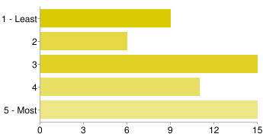

[Illustration of question #16.2]

News apps

The third category was called News and included news-reading, RSS feed and podcasting apps. Here, the highest number of ratings was at 1 (19%), with the number of ratings gradually dropping all the way to 5 at 10%. This tells us that the students use these applications, but they are far from most popular and are also used fairly infrequently.

Social Networking

The final category was the category of Social Networking (see illustration of question #16.4) and included apps that allow access to the most popular social networking sites, like, for example Twitter and Facebook. Here, the response was overwhelmingly positive, with 45% rating these as very important and 14% as fairly important. The last three options varied insignificantly between 4 and 6 percent. This result was predictable and is also important for our project, as the application we are developing adds a degree of sociability. The results of this question are therefore also fairly optimistic for us.

|  |  |
| --- | --- |
| Beskrivelse: C:\Users\Ejer\Downloads\16.4.png | 1 - Least **5** 6%  2 **3** 4%  3 **3** 4%  4 **11** 14%  5 - Most **35** 45% |
| [Illustration of question #16.4] |  |

Most personally important apps

In one section we asked the respondents to list the apps they cannot live without, or apps that are the most important to them. They listed a fairly large number of mobile applications covering most categories. However, several apps were named more than one time, indicating heightened interest in those apps. Most often the respondents named the social networking apps as the most important, Facebook being present in almost every answer. Other most popular choices included Twitter, YouTube, Skype, Angry birds and e-banking applications of various banks. The results of this question further point to the increasing interest in social media.

Potential concept viability

Our final question described the concept behind our app and asked whether it would be used by the survey participants. Here, 62% responded positively and only 13% negatively. This means that the app would be fairly popular, at least among this particular group of students. A few students commented the survey;

* "I generally find that there is a huge lack in a social site or app which gathers different information concerning student bars, and perhaps later on, events as well.”
* “It would be great to have a place where others can easily recommend places, and show where they are."
* “Good point would be to share events, with description (closing hours, prices)...”
* “I'm quite open to inspiration from both friends and review sites.”

They actually pointed out most of our ideas we discussed when we decided to make the application, which will be described further in the report.

## Survey conclusion

Market presence

By analyzing the answers to the survey it is possible to make a number of conclusions that are relevant to our overall plans as well as the product produced. The most important one is that there is definitely a considerable market for our product, which in turn has many other implications.

Another thing worth mentioning is the fact that our product is indeed commercially viable and we can expect to stand some profit from its development and publishing if we use the right business strategy as well as if the product meets the potential user expectations. The information from the survey could be used to aid in accomplishing both those things.

This also means that it is possible to potentially expand, especially if the given public is mostly similar to the one we questioned. It would be beneficial to hold that in mind while looking for new markets and niches.

Business strategy

The second conclusion that could be drawn is that the concept of our application is actually viable and definitely solves a problem that other applications haven’t addressed. This knowledge enables us to not only cater more effectively to the public, but to claim a fairly untouched niche and further establish our dominance in it by later adding more complex solutions.

Another important conclusion is that the overall popularity of solutions that we utilize within our application is, in fact, high, as we expected. This information is mainly important in a marketing sense, since it allows us to further attune our decisions and actions to the needs of the costumer. We also found out that the trends we predicted are, indeed, for the most part in effect, which further goes to verify the accuracy of our results.

Relevance of app functionality

By taking a look at the factors that contribute to the frequency of bar visitations and the choice of the bar, we can definitely conclude that there is a need for specific information about a bar, an individual in planning to visit before he/she visits it. This could potentially be beneficial for costumers, small business owners and even communities, seeing how this could cause improvement in overall bar quality.

The choice of the bar is worth a separate mention for the fact that the overwhelming majority of responses are social-based, meaning that the respondents are influenced by friends or other people that surround them. This can definitely be utilized in the development of the application, as well as making it the central point of the app as well.

More students are growing sensitive to the number of people in the bars they visit, emphasizing once again one of the main points of our application. We can only conclude that implementing it in one way or another would be a wise development choice.

Overall, the response from the survey definitely demonstrates that there is a need for the application, that the application solves a particular problem and that there is an existing market for applications of this type. Also, the direct question about the usefulness of this app also gave overwhelmingly positive results, once again encouraging its development.

# Designing an Android application

When designing an app for a smart phone one should investigate if the platform used has any guidelines which must be followed. These guidelines can first of all help the designer figure out how to draw specific objects that enables them to fit the specific platform with the outcome of the best experience of the user. In this case the Barr App is programmed to an Android platform as this has no guidelines which must be followed, only guidelines which are suggestions to any programmer. This next section will tell about designing an application in relation to different guidelines and research papers about terms which are often used when designing.

As the book “Interaction Design – beyond human-computer interaction” shows, that the key of interaction design:

“Recognizing and understanding the nature of the relationship between usability and other user experience goals is central to interaction design.”   
 Rogers et al. (2011)

This leads us to argue what user experience and usability is:

1. A user experience is a consequence of how the user feels at the exact moment he or she uses an app and how the app is designed, and in to what context it is being used in (Hassenzahl and Tractinsky (2006)).
2. The aspect of usability is related to questions about how an application functions in relation to what the main goal is for it (Hassenzahl and Tractinsky (2006)). Is it to provide a user experience or is to prevent usability problems? Does the app provide the user with the information he/she it was intended to deliver?

From the perspective that Hassenzahl and Tractinsky (2006) gives – an aspect to consider when making an app is; to design for pleasure is to design a good user experience. One should then consider what the pleasure/experience the app should give the user (Rogers et al. (2011)). Hassenzahl and Tractinsky also state that beauty satisfies a general human need ((Hassenzahl and Tractinsky (2006)) extended from (Maslow (1954)).

There are other aspects to consider when designing an application which is meant to be used by the public. Intuitive design allows the user to learn how the app functions without giving any instructions verbally or written. The intuitive part is often instructed using nonverbal images/icons, which the user already knows from other apps. In this way the user has already learned what an icon represents and can easily navigate through the basics of a new app using familiar icons. A good application is not always completely intuitively designed, but sometimes the user has to learn how it functions (Mobile Design for iPhone and iPad (2011)). This way of designing is not easy, but it will help the user understand the basics of the app. The user can then try their way around the environment of the application to understand all the different functionalities of the app.

One should consider a few things before finishing a design. The first thing to consider is adding physically and realistic dimensions to the app [12]. This will provide the user with an experience of the app being natural and nice looking and in the same instance obeying the physical laws of nature. If an effect is not natural or is too unnatural the user will be disorientated, if e.g. a movement animation defies physical laws [12]. An application could use images of leather or some other material to give the user the impression that this is real and not some second hand device. The second thing to consider is to hire someone else to do all the nice graphics if you are not able to do a good job yourself [12]. The reality of the market shows that an app that is not nice to look at - is not regarded to be anything else than a poor try. The third thing to consider is about the usability. Users of smart phones can often choose to view an app [12] in both portrait mode [Example 6.1] and landscape mode [Example 6.1] [Example 6.2].

Portrait  
mode

Landscape  
mode

[Example 6.1] [Example 6.2]

But this might not be the primary concern of a designer, but it is important to address this, because the designer has to know/decide in which mode the app is intended to run. Some application like Facebook for Android, Dropbox etc. can be viewed in both modes.

**Guidelines** (GL) are used to guide developers. When referring to Android GL – they are voluntary to use, and simply good ideas of what might be good to use. When referring to iOS GL – they are mostly mandatory [13], because the Apple store must approve your application before it is published in their store. This is not an issue in this project, because the platform aiming for is the Android one. When looking at the iOS GL published on the iOS developer site [12] - their ideas about esthetics are preferable in the line of students represented in the project group. One should again note that the app created in this project is not based on that particular platform, but the popularity of Apple’s products gives the strong impression that the good ideas could provide the project application with some issues or great ideas when designing. Adam Beckley (in his Android design GL (Beckley, 2011)) also states the importance that one can’t consider iPhone apps (iOS) to be directly portable to the android platform. This means that one should not blindly add functionalities from the iOS platform to the Android platform without considering if the Android users are able to understand the meaning of it.

This next section will list and elaborate some guidelines from various sources such as official/unofficial guidelines and research:

* One should maintain focus on the primary content [12].
  + The content of the app should be viewed very much alike as a mobile web page is. It should be exact with information without any secondary information to distract the user. That means that one should decide on what is essential in the app, what does the user need to know and what is secondary information (Mobile Design for iPhone and iPad, 2011).
* Do not go against conventional designing methods – this will only confuse the user, and try to make them re-learn how to work an app (Mobile Design for iPhone and iPad, 2011).
  + This refers to the intuitive design discussed above. If the user is already used to use an Android platform – the user might be confused if the application is based on only iOS guidelines and this goes for the other way around.
* When the user offers an input - the app should provide feedback to the user instantly [12].
  + An example of this could be to press a button and the icon changes or the app makes the phone vibrates. This provides the user with the acknowledgement that the system knows that you made an input and is working on it.
* Start the application without a splash screen if possible. And if it is not, it should resemble the main start page. This will not confuse the user, but make the waiting time seem lower [12].
* Effectiveness, Efficiency, Safety, Utility, Learnability, memorability (Rogers et al. 2011).
  + These are a few criteria to take into consideration. Taking these criteria in to account when designing, will help designers prevent design problems and conflicts (Rogers et al. 2011) which might not be discovered before the users complain about them.

The relationship between usability and user experience design can be describes as a man that takes a bite of an apple. The ability to bite the apple is *the usability* and will create problems for the man, if his teeth are in bad shape. *(If the conditions are not good, there will be a problem)* The apple represents *the user experience* when the man bites the apple. If the apple has a good flavor and is without any major flaws, it will taste good to most people who like apples. Translated into plain English this means; if the application is well made without any disturbance from major flaws (*which mean that the usability is good*) and the goal of the application is create a good *user experience*, then the application and content will “taste good” or be used by users other than the developer himself.

# The Android platform

Android - Open Source benefits/disadvantages

**Benefits:**

Barriers [14]

As a new company developing applications for mobile devices it might be of high interest to have the lowest costs possible. This is where the Android platform has its benefits because it is possible to develop apps without spending any money at all if you have a computer. The software developer kit (SDK) is completely free and there are lots of free written and video tutorials concerning development of applications available on the internet.

Companies creating for mobile devices [15]

Also Android is very ideal for companies that are playing with the idea of going mobile and creating applications for mobile devices because it is only needed to have a working knowledge of Java to create Android applications. There are plenty of Java programmers available in the market because of the economic state at the moment.

Distribution [16]

As a developer it is good to use Android since there are a variety of places to publish a new made application. It is not only in Google’s Android Market the Android applications can be released but also in other third party application stores. This means that applications are not controlled if they add viruses or Trojans. Depending on what the goal with the application is - there are application stores for almost anything and it is the users’ responsibility to judge if it looks secure/valid. The end user can find applications throughout the internet so it is the developer’s responsibility to add the right tags to his/her application in order for users to find them using for example the Google Search engine.

Open-source platform [17]

One of the main advantages about the Android platform is that it is totally free, no licenses needed and no royalties must be paid. Most developers test their application using Beta-testing. Beta-testing is a group of people testing the application in action to see if there are any bugs or anything that needs to change. The testers then give feedback to the developers and this may raise the quality of the application when releasing it. Last but not least it is possible for the developer to customize the complete platform and its features for a better user experience.

Quicker development

Since Android is open-source it is not needed to get approval for releasing a newly developed application on the Android Market. This means that the developers do not have to worry about an approval part, which might take a lot of time – and go directly to the release of the application and thereby also get feedback on the application in an earlier state, which will mean faster development and optimization of the applications in Android Market. Also this means that there are a lot more Android applications than iOS applications. There are over 500,000 iOS applications [18] within the App Store compared to the Android Market where more than 10 billion applications has been released.[19] It is clear that the fact that Android is an open-source platform gives developers free hands to release anything they want.

**Disadvantages:**

10 billion applications in Android marked [20] only 7 billion of them have been downloaded[21]

The Android Market contains over 10 billion applications but it is estimated that only 7.06 billion [21] applications have been downloaded from the Android Market so far. This leaves almost 3 billion applications in the category of not yet downloaded applications in Android Market. This might mean that developers are releasing anything (also applications that might be nonfunctional). The question is if it is a good or a bad thing that anything can be released. The fact that everyone can release applications in the store can cause the quality of the average application to be extremely low which will eventually give the user an overall negative experience.

Open-source opens up for viruses

There are applications which can control the existing operating system (OS) and because of this the developer could in principle create viruses/Trojans hidden inside the application. It is very simple to put in a line of code when writing the application that will send the developer personal information as account-names and passwords from anything that might have something to do with the application made, without the user knowing anything about it.[22]

iOS - closed source benefits/ disadvantages

**Advantages:**

Not so many tasteless applications

Since iOS is a closed platform there are way fewer applications but they have all been approved by Apple’s approval polices which means that these applications are up and running like they were supposed to without any nasty surprises.

More profitable

From a developer’s point of view, closed source is more profitable since it is possible to neglect competition because it is possible to deny other developers access to your source code and thereby design, though if other developers really want to use the API (Application Programming Interface) of the particular application the developer can demand payments for the use of it.[23]

**Disadvantages:**

Slower development

The open-source provides a lot of help for newly started developers. The new developers will be able to look through all of the source codes in the Android Market to get inspiration. Also when a new application is developed the other developers can give feedback on the application helping the newly started developer to improve which is not the case with closed-source, in fact it is the opposite.

Approval process

Last but not least it can take a lot of time to get an application approved by Apple’s approval police. If Apple is not satisfied with the application that is made they can are free to reject the application and the developer will have to think of ways to improve the application for it to get approved and released on the App Store.

Compatibility

One of the greatest challenges of the Android platform is the immense amount of fragmentation. It is a fact that not all manufactures keep the phones they create up to date in terms of the firmware. In fact in a recent comparison of *Android & iPhone update history*[7] by Michael Degusta it is made clear that “7 of the 18 Android phones never ran a current version of the OS”, and even more worrying “11 of 18 stopped getting any support updates less than a year after release.”[24] And it should be noted here, that these devices are usually sold with a 2-year contract in the United States, where data originates.

But why is this bad?

**From a developers point of view** this means that you have to take in to account that some of your potential users will not have the latest version of Android installed.

Based upon the chart below we can as a developer choose the version that is at the very top of the chart, and thereby ensure that our application is compatible with 100% of active devices (and all future versions), because all Android APIs are forward compatible. By choosing to develop for a version lower on the chart, we thereby achieve a lower compatibility percentage as indicated where the line for the specific version meets the y-axis.

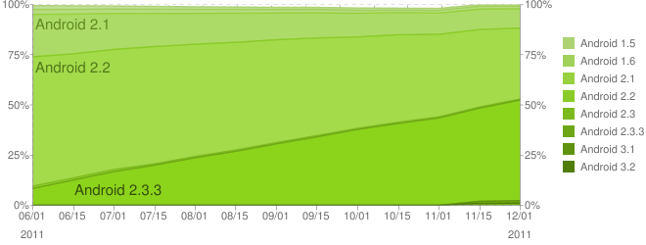

*Last historical dataset collected during a 14-day period ending on December 1, 2011* **[25]**

[Example 7.1]

We can therefore choose to develop for the third top most API level – 7 and by doing so almost achieve a compatibility rate of about 98% of all Android phones connected to the Android market as specified by the chart. Whereas choosing Android 2.3.3, which our developer phones shipped with, we would by worst case lower our compatibility rate down to almost 50% of the phones.

The main disadvantage posed by the so-called android fragmentation is that developers have to sacrifice the features made available in newer versions to ensure compatibility. In the end this not only makes the life harder for the developers, but ultimately also affects the product the end user receives.

From the users point of view

If a developer chooses **not** to go down this road of higher compatibility, the user is unfortunately put in a situation where the outcome is either a warning sign that suggests that the app may not be compatible and work as intended or simply an app that can’t run on the phone. The user can from here go either two ways assuming the manufacturer has stopped all support. Buying a new phone or *rooting[8]* the device the install an unofficial distribution of the operating system, which by most people would be considered unconventional and potentially void the warranty of the phone.

From the manufactures point of view

It is a widely held viewpoint [26] that many manufactures don’t have any incentive to update the OS due to the fact that they do not make any money after the hardware sale. And this might be single root to all the problems concerning fragmentation in the Android platform. The choices made by the manufactures affect both the developer and the end user.

# Design description

Our application allows users to find student bars in Denmark. The idea behind the design was to make it accessible and easy to use, focusing on having as few buttons as possible displayed on the screen, but keeping it practical at the same time.

When the user launches the application it will not be required of him to type in any information to get an overview of nearby bars - only the function of retrieving data from the internet is required using WIFI or Mobile Data. A map shows the user’s location as well as markers which represents student bars. Information about a bar is fetched by selecting a marker. This information is displayed in Bar information view. All the views are displayed in portrait mode (as explained in the designing an Android application section), because we had some problems with the application resetting when changing the orientation of the device. This also allowed us to not consume time on the draw9patch function in order to get all the images looking right in every view when displaying it in landscape mode.

## Ways of finding student bars and scenarios

Others ways of finding student bars in Denmark are: specific Internet search, commercials / banners either in buses, train stations, around the walking streets of Copenhagen, or on websites. From all of these, the Internet search is the most viable option that does not rely on chance. There are a few websites that show the top bars in Copenhagen, like:

* <http://www.europeanbeerguide.net/copepubs.htm> [27]
* <http://www.worldsbestbars.com/city/copenhagen> [28]
* <http://www.nileguide.com/destination/copenhagen/best/bars-and-clubs-type/bars-249> [29]

But it must be taken into consideration that there are no lists of student bars from Denmark on the Internet and the majority of student bars do not have websites of their own, so this is where our application comes to use.

Scenarios

1. If one finds themselves in the city and looking for a student bar, our map view displays the nearest student bars to the mobile device on which the application is running, along with directions on how to reach the bar.
2. A group of students are at a student bar. They just found out that it closes in an hour. Using our application they can check out the nearest bars and see if they are open according to the bar information view.

Scenario 1 incorporates the basic functionality of the application. And it is the foundation behind our idea to develop an application that aids the user to find student bars as quickly and efficient as possible.

Because of scenario 2, we came up with a new function that could further help the user find bars easier in scenario 2. The function would be a filter function which could filter out the bars that are not open or are not located in a distance acceptable for the user. The idea is not implemented in the application because we did not have the competence to make it and the time required to acquire it.

User requirements

Based on the survey and the state of the art analysis we were able to define a number of features that are essential in order for the application to have any success among the users. These were split into mandatory and feasible requirements based on our expectations and timeframe:

|  |  |
| --- | --- |
| Mandatory   * Views of bars:   + Map   + List * Bar Information:   + Contact   + Prices   + Opening hours * Partial Facebook-integration   + Friends location (check-ins) | Feasible   * Filter / Sorting * Deep Facebook-integration * Facebook Canvas app   + Adding and Administering bars * Proximity Check-in * Aesthetically pleasing design   + GUI   + Logo   + Name |

The map view

The first and most vital feature is the actual retrieval and display of the bars. Using a map we can visually display the proximity as well as the locations of target bars, something, which is obvious and done by most competitors.

Our current implementation of the map view (see [Example 8.1]) Utilizes the internal GPS system within the Android device to center the map accordingly to the users current location. We provide the user with the option to set a new start point by either filling out the text field and pressing the search button(see [Example 8.1]) or by performing a long press on the screen which opens up an AlertDialog (see [Example 8.1]) which reveals further functionality within the map view.

Setting a new start point is useful for example when the user knows that they are going to visit a bar after they change location. In the top right in this view a button for a list view is displayed, but this feature is not yet implemented due to programming difficulties.

It is possible to change the view mode from a standard map to a satellite view if the user has a need to see the map in another viewpoint.

The third option within the Alert dialog allows the user get address of the touched point on the map. We chose to include this as it is might be useful at given situations and because it was fairly simple to implement as it is used several times in the application.

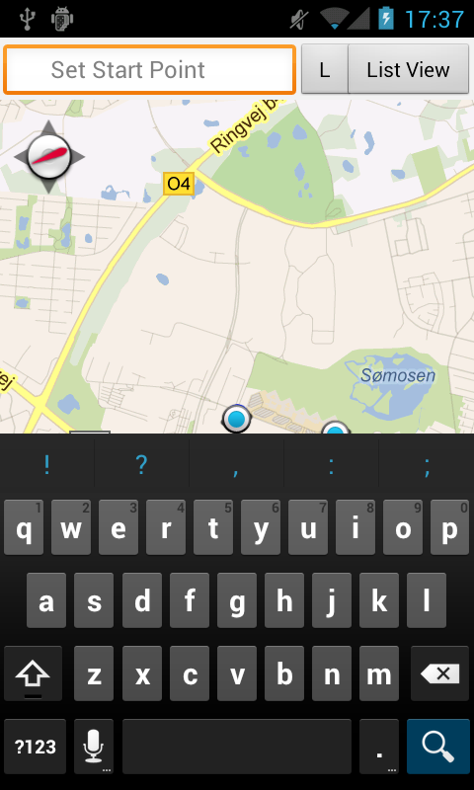 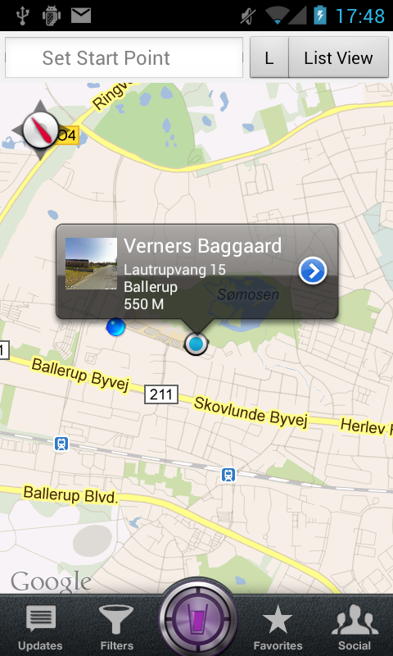 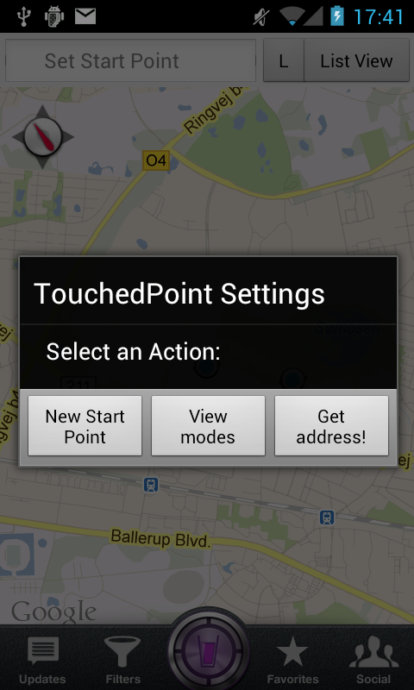

[Example 8.1]

We chose Google Maps as our map provider for several reasons:

* **Documentation** – Google Maps is well documented and used widely by many developers. This gives us a higher probability of finding solutions to problems and guides that help solve specific programming difficulties.
* **Popularity** – Due to the popularity of Google Maps the users will be able to recognize and feel familiar with the interface. This is useful from a usability point of view.
* **API** – Provides a long list of useful methods, we as developers can utilize and build upon. Some of the used in this project are:
  + MapView – Is the actual map object.
  + Overlay – Allows us to add overlays to the map.
  + Geocoder – Allows us to transform a street address or other description in to a (latitude, longitude) coordinate and naturally the opposite, called Reverse Geocoding.
  + OverlayItem – is an item we can place on the overlay we create.
  + Mapcontroller – Allows us to control the map and programmatically navigate to another point on the map.

Marker and bubble

Each marker represents a bar and the user can click on each marker to see the name of the bar. If a marker is selected by a simple press, a bubble will appear and show the name of the bar together with the address and distance from the current location of the user. If the user wants more information they would have to press the appearing bubble and they will be directed to another view inside the application that displays more information concerning that particular bar (Bar information view).

For the balloons that appear when the markers are touched, we used a package from Github created by Jeff Gilfelt, that contained some Itemized Overlays and a default MapView. We modified the OverlayItems to suit our needs and added them to our own MapView. The markers which we added ourselves are receiving their latitude and longitude coordinates from the database where we stored the bars’ information. (Parse).

Bar information view

One of the other mandatory requirements is the Bar information view. Here the user is provided with an overview of the most essential information about the bar. We have been sure to include prices and opening hours as these were confirmed to be somewhat important or really important according to our survey.

As we did not have the option to extract information about the student bars at one central place, as this does not exist we had to find a solution where we could add and change the information we could find about the different student bars. These so called previously referred to as Bar data should be stored in a database to allow us to make queries that would return the request made by our different methods.

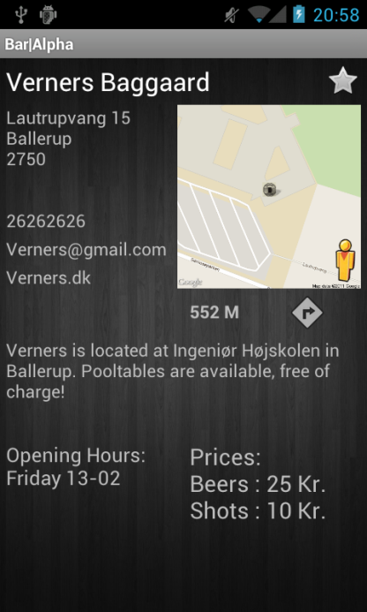

[Example 8.2]

As we didn’t think our prior knowledge about databases would be sufficient we settled upon a service called Parse. It gave us a web interface from where we could add our data about the bars and allowed us to make queries that would retrieve the relevant data.

The bar information view (See Example 8.2) displays the following:

* **Bar name**
* **Address of the bar**
* **Contact info**
* **Distance from current user location or set of start point**
* **Bar description**
* **Picture of a static map with a marker at the bar location**
* **Icon that will navigate to the bar**

Besides Contact info, opening hours and prices were chosen to be mandatory as our survey confirmed our need for these:

* **Prices -** None of the tested apps displayed a price list of what the bar offers here in Denmark. BarFinder offers the option to let users add the prices, but none of the bars here in Denmark had anything listed. A few of the apps did though have prices in form of discounts or so called happy hours specials.
* **Opening hours** - When looking at our comparison table we see that DrinkOwl is the only app out there that lists the opening hours for every single place in their solution. By having this same feature we can ensure that our users know the opening hours of a bar and as something unique we could incorporate this as a filter option in future versions.

As mentioned in the «Designing an Android application» section, we considered that the navigation should be easy to operate. In the beginning, when we first started to work on the designs for the application we considered making the picture in this view clickable. This would mean that the user had to know that he should press the picture in order to be navigated to the bar. But after looking into usability and user experience principles we discovered that it would indeed confuse the user and not help in quickly learning about that function. To make it somewhat more logical we added a street view icon, also known as the “pegman”[30], which a competent user of Google Maps would recognize. By incorporating this feature we can open up a street view Intent to provide the user with an alternative way of navigating around and perhaps recognizing the place.

Use of Android Intent handlers

The average user of any mobile or computer device expects that URL’s, emails and in some cases phone numbers can be copied or have some kind of functions when interacted with using a mouse or by a touch with a finger. We used Android’s own intent handler so the websites and phone numbers in the Bar information view link to respectively a new browser window with the URL inserted or to the dial phone with the phone number already inserted. If we did not have these methods implemented the user would maybe think that the information was somewhat useless, because he expects it to act this way.

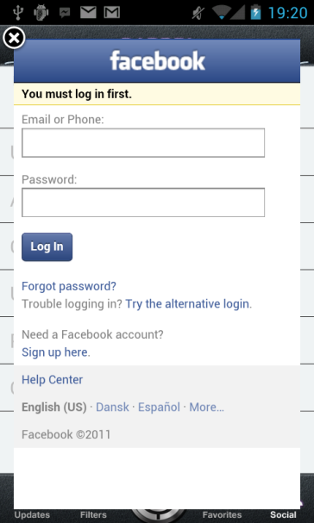

[Example 8.3]

The social view

Another vital feature is the social connectivity and integration of the application into the best-known social networking services, which is the most important as we as the most popular feature according to the results of our survey. This has been accomplished within our app to a certain extent.

The social view mode (See [Example 8.3]) lets the user login to their Facebook account and is thereby access various features using their Facebook account as the access key. They can update their status and at the same time our application will be visible to any user that sees the post. The user can also check in, which will appear as a post on their Facebook wall – with information about where their location was when they checked in.

The Menu

A graphical user interface that is both simple and functional is also one of the key features of our application, as well as having been done by most, but not all competitors. It is worth noting that the lack of an attractive-looking UI may cause hesitation when the user browses for app on the Android market.

We have put work into the elements that are seen the most within the pages of the app. The menu is one of these.

The menu (see [Example 8.4]) contains different functions. We call them Updates, Filters, Map, Favorites and Social. They will, according to their name, navigate the user to the view mode that corresponds to that button.

1. Updates; is the first page the user sees when launching the application. It displays the updates view.
2. Filters; displays the filter view.
3. Map; displays the map view.
4. Favorites; displays the favorites view.
5. Social; displays the social view.

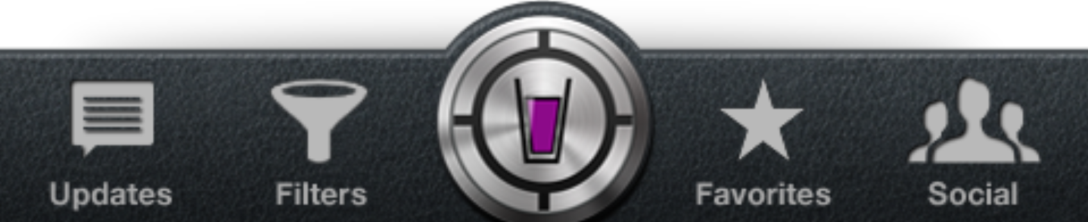

[Example 8.4]

The design idea behind the menu is to emulate the texture of leather. This makes the application appear more exclusive and give a good first impression when the user launches it. To give a better overview to the user the different buttons change if you press one of them. This means that the user can easily see which view is currently showing. The icon and the text below changes from a grey color into a white color with a small purple outline and a small triangle are also shown as a further indication of the selection.

Filter view

Inside this view the user can select, judging by distance in kilometers, the radius in which the bars will be displayed. While using the seek bar, after changing the distance, the application will show a message telling the user, before going into the map view, how many bars will be displayed and add the markers to the map.

Naming

The use of the words Beer, Bar and Finder are quite obvious as they are keywords users would search for when looking for an application to locate bars. But it is noticeable that the combination of Bar and Finder is the most common as it appear three times, at least in our test of competing products. It is important to have relevant keyword(s) in the name for search engine optimization (SEO) purposes, but on the other hand it should not be confused with another product, which it would if we went with the name “Bar Finder”.

As the current implementation of our app is based upon locating student bars we could choose a descriptive name such as “Student Bar Finder” or perhaps “University Bar Finder” but going down that road often “leads to a generic and forgettable name” [31.

We choose to settle on a shorter name, as this would look more aesthetically pleasing on the launcher screen of the phone and inside the app. We ended up with the name BarAlpha, which in some ways can draw parallels to the “computational answer engine” Wolfram Alpha [32], but also the word Alpha slowly became a natural part of the app name due to our versioning approach to the app which started at Bar_A1, Alpha 1, and continued through the development cycle currently terminating at A9 or Alpha version 9. In many ways our app name is an internal codename within our development team. In a commercial setting we would consider changing the name, but not to waste more of our precious time we decided to settle upon BarAlpha.

Logo

We wanted the logo (See [Example 8.5]) to highlight the main theme of our application, bars, and at the same time the locate function. What better way to illustrate a bar other than with a pint of beer, and the crosshair built on the outside as this is often he precision with, which our application locates the user and the surrounding student bars. Our first idea fit as well on our color theme of our app so we choose something that would accompany our leather design. We ended up with a logo that in many ways had the same elements as our first design but in another texture.

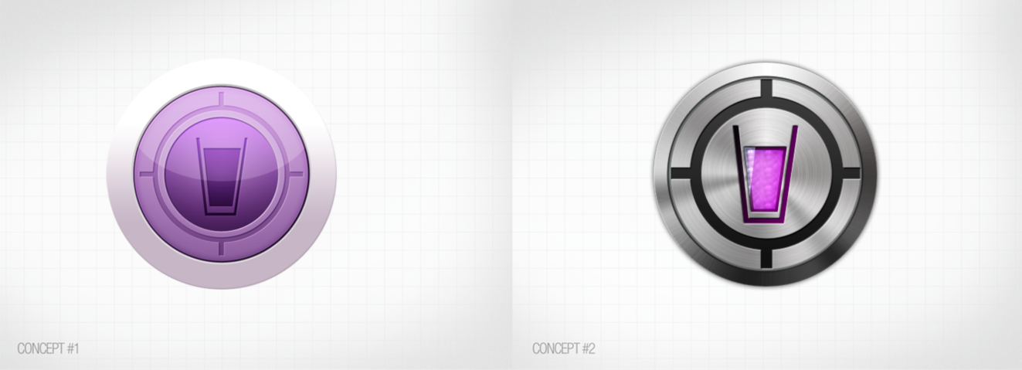

[Example 8.5]

## Unimplemented features

There are also several other development decisions, which are considered relevant, but have not been addressed in this version of the application.

The bar update view

The bar update view is the first view that the user sees when launching the application. What this contains is a list view where the latest updates from bars is displayed. These updates are actually wall posts from all the bars which are added to our database.

More advanced filter view

The filter view (See [Example 8.6]) helps the user to cross out bars from the initial list of bars that are displayed on the map or in the list view.

Filter properties:

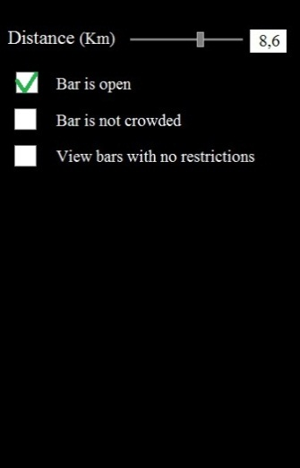

[Example 8.6]

* Distance in kilometers. This is adjusted using a slide bar. And there is a counter to view the desired distance and to type in a desired distance if the users prefer using this instead of the slide bar feature.
* Availability: a function that checks the phone clock and searches if it is within the opening hours of the student bars.
* Crowdedness: a function that checks if the student bars viewed from the database are crowded and leaves out the ones that is.
* Restrictions: a function that checks if the student bars have restrictions like; only allowed for students of that particular study.

List View

One could choose to view information about distance and bar names by choosing the list button. This will show a map list view (see [Example 8.7]), where the nearest bars are displayed by name and in order of the distance. One could press the name and be navigated to the Bar information view belonging to the bar, or one would like to place the bar in one’s favorite view by selecting the star logo. The star logo will appear white when it is not selected as a favorite bar, and will appear yellow if it is selected as a favorite bar. From this view one could select a bar to be implemented in the favorite list.

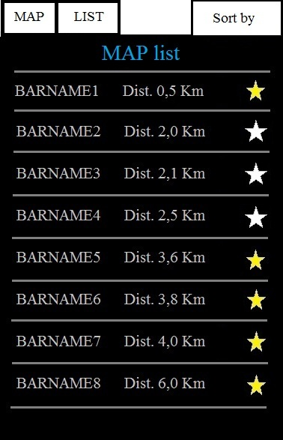

[Example 8.7]

The “sort by” option can let one view the list in different ways:

* Alphabetic order
* Distance (viewing the shortest distance first)
* Opening hours (which bar has the longest opening hours)

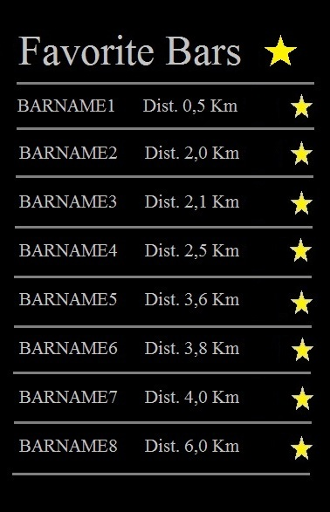

[Example 8.8]

The favorite view

One would be able to view favorite bars by distance from current location and one could check of any bar in the list by clicking on a star logo, meaning that the bar then would be removed from the list of favorite bars. These functions with stars meaning favorite is a common feature in all Android devices, so we would count on the user to understand this feature from the first time he sees it. Further information about the bar will be displayed if the user presses the name of the bar. (see [Example 8.8]).

The Social view

The social view was intended to be a view mode where the user could login in using their Facebook account and then be able to check in to student bars. Furthermore the check-in feature could be automated by using proximity alerts that would detect the user when in a defined radius of the bar. This would of course pose some privacy issues and should therefore be for the user to decide. At the moment the social features are not implemented as it was prioritized as one of the last features to implement due to our timeframe. A copy of our initial specifications list is added as an appendix.

The bar information view

(See [Example 8.9]) The drink logo, in the upper left corner shows how crowded the bar is, green being almost empty, going towards red which is full. The golden star in the upper right corners allows one to add the current selected bar to the favorite list. One can view three different screens on this view by swiping the screen with one finger from one side of the screen to the other. Further description is as follows (See [Example 8.9]).

* Number 1; this view shows what other users have written while checking in to this bar.
* Number 2; this view shows general information such as the address and opening hours. And it also shows a quick view of where the bar is located.
* Number 3; this view shows prices and information about events created by the bar using their Facebook page.

**1                                        2                                       3**

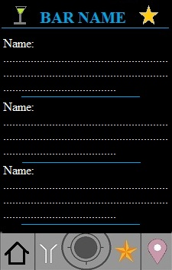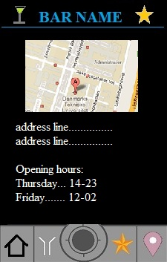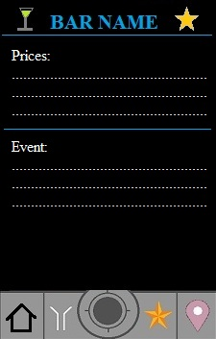

[Example 8.9]

# Tools used in development

****Photoshop****

We used this software to adjust or modify pictures that we could later use in the application’s design. The main menu, which is displayed on the bottom, was created by cutting a whole picture into five different pieces, each one representing one of the buttons. The pictures were then inserted into Eclipse as pictures which can be drawn in the layouts.

****Parse**.**com****

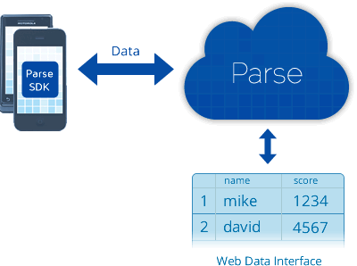Parse.com is used to make a database without making any database programming ourselves. The vision of Parse.com is exactly this [33]. They made a SDK which enables developers of both Android and iOS to get information from the database which the developer created within their website. We typed in all the information about the bars in the database and the information is then retrievable when the user selects a bar in the map view. This way of making a quick database really helped a lot when we made the applications because we did not have to set up a new database from scratch (see Example 11.1 for a visual description). Another feature that has just been released (Dec. 9) [34] is Geo Queries. This function is used to associate location with data. What this means is that the list of bars retrieved from the database depends on a defined radius of the user location, instead of retrieving everything in the database at the launch of the application. A user could thereby specify how long he should to travel just by adjusting the user defined radius. Furthermore Parse.com provides other features which are not implemented in the application at this state. One of the features they provide is Push notifications, which can be used to inform users about friends attending a student bar on Facebook, which would then help students to decide on which bar to visit. We did not use this feature because we did not have the time.

[Example 11.1 from Parse.com]

****Eclipse****

Eclipse was used in this project as the code editor and the compiler for the application because it is free and the tutorials we have used to learn about developing in Android are often showed in this program.

****Google Maps API****

Google Maps can be delivered to any mobile phone that has a full Java implementation using the Google Maps JavaScript API. For incorporating maps in our Android application we used the Android Maps External Library which is included in the Google APIs add-on. This add-on can be automatically installed by the Android SDK package. If it is not preinstalled, which was our case, we had to use the SDK and AVD manager tool to install the Google APIs version 2.2, because we are developing on Android 2.2.

After installing the add-on we had to add Maps capabilities to our existing Android project in Eclipse, by setting the properties of the project to use the Google API as a build target [35]. For the application to actually connect with the Google maps we had to reference the library by inserting a line of code inside the manifest:

<uses-library android:name=”com.google.android.maps” />

Furthermore, for the map to fully function when the application is running, and not just display a static picture of the surrounding area of where the device is located, a Maps API key [36] is required. The key must then be placed in the main.xml file inside the project.

****Facebook SDK****

The Facebook SDK makes it easy to implement Facebook functions into an Android application. They made it so that for example to update ones status using another application but their own is easily implemented and thereby making their own business even bigger. It is also free to use like the rest of the Facebook features on their web site.

****Alpha testing****

Alpha testing involves tests run by the team of developers or the client who ordered the software. In our case we were both the developers and the client, so we made all the testing every time we wrote a new piece of code. If we did not alpha test it along with coding, we would properly not have anything working, because the theory and tutorials we looked up where not always feasible. A negative side to this is the fact that we did not have any Beta-testers to test the application in ways we maybe did not think of. So there might be some errors we did not foresee.

# Future development

This section will tell about some of the ideas we came up with during the development of the application. The ideas did not get implemented at this point because the scheduling of the project did not allow us to do so. Some of the ideas below are guesses to what could be implemented in the future. Others are elaborations to previous ideas discussed in the report.

****Profile****

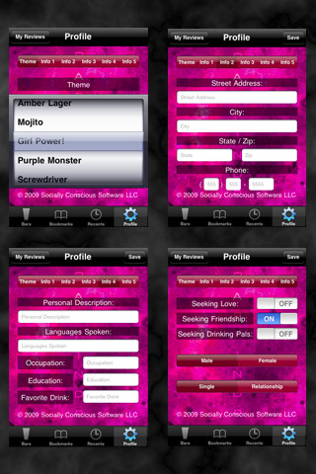One of the interesting ideas we found in a bar finding application was the profile management. In comparison to our Facebook login, they have their own server, on which they store the profiles of the users and they created a special button for this function in the application. It has most of the Facebook profile features like name, address, date of birth, occupation, description, which we could also integrate in our application. If someone checks in at a bar, his Facebook profile picture would appear on the bar page, and from there, people who are checking out the bar page in the application can click his photo and see that person’s Facebook information.

The Bar Finder Touch application has one of these profile management options and this application also grant the user the option to state his interests and somewhat socialize and meet other people with similar taste. This is a feature we might consider implementing later into our project, also because of the survey results which point to an expanding interest in social media. As seen on the picture on the left taken from the Bar Finder Touch, the profile part of the application consists of 4 views, each with a different functionality. In the first one (top left corner), the user is given the option to choose from various themes, which mainly involve changing the background color. In the next views he can give a description of himself, as well as state his address and interests.

****Distance**** timer

Next, concerning the Google maps which is implemented into our application; we could add a way of calculating the time it takes the user to travel a certain distance, because if, for example, they are planning on meeting someone at a bar at a certain hour it would help to know how long it takes to reach that bar from the user’s location. Furthermore, we could set up special routes from one student bar to another, so when the user checks-in at a bar, the application will suggest where he/she could go next, searching only for the nearest bars with similar music or offers. This of course involves further development to our database and filter function to include music types.

Crowd and review

Unfortunately, due to the lack of time and after looking at the survey results, we decided to leave out a few of the functions and buttons. We could reconsider implementing the crowdedness button in the future, which didn’t seem to interest that many students. The idea was to have a round shaped button in the corner of the bar page and what this does is show how many people are in a bar by changing colors from green, which represents few people, yellow – medium and red – very crowded. But for this to work properly, the bar owners or bartenders should find a way to regularly update their bars’ Facebook page with this specific information, so we can use that further in our application.

Also, we could add a review function, which allows the user to describe his/her experience at one of the bars, recommend and rate them. What’s more, we could combine this with the profile development, so the user can find people that gave appreciative comments and rates regarding bars with similar characteristics. One of the conclusions of the survey was that students tend to go out to bars with university colleagues and they visit mostly the same bar. This function of the application would give them a great chance of meeting new people outside their university and discover new places to enjoy.

# The design and development process

In the following part an attempt at explaining the structure and design of the application is made. The following is based on the method of developing a design document as presented in the book “Object Orienteret Analyse & Design” 3rd edition 2001 by Lars Mathiasen. A few points have been omitted for brevity of the report.

A design document is a document explaining the intended structure and functionality of an application to the developer(s), to ease development in larger teams, by clarifying which classes should be depend on each other, inherit from each other, pass along, modify or display data. As well as lay out the design-structure of the more advanced functionality of the application.

## Analyzing ****the**** application – a design documentation

The BATOFF-criteria is a support-method when developing the system definition of an application to get and overview of what the system should do in general, the environment in which it should be used, the users who will be using it and the hardware requirements which preferably should not be exceeded nor should be less than it can be run on the devices targeted, that is in our case, that our application should not use any API's not supported by the decided Android OS system, or any hardware features not included on the targeted system on which the application should run. This could be utilizing multi-touch capability or a micro-HDMI-socket or something which some phones do not have or might support.

The BATOF- criteria is the Danish abbreviation of the following points, which we have translated as CUTOFP for consistency of the report.

****BATOFF****/****CUTOFP****

**Conditions:** The system should be simple and user-friendly, so that users intuitive can get the information they need.

**Users:** University students in need of locating their own or friends’ student bars.

**Technology:** Should as a minimum be runnable on android phones running Android 2.2.

**Objects:** Map, Search/Filter, Bars, location.

**Functions:** Make it possible for students to find the nearest bars and get information on their opening hours, prices and get travel directions etc.

**Philosophy:** A student bar Locator and Information viewer.

## System definition

The system we have been developing is a java-application targeted for the Android smartphone. The applications purpose is to conveniently assist students finding nearby student bars which are open at the given time, as well as getting information about the bars including drink prices, opening hours, address, contact information and the like. The system should be intuitive and easy to use as it is to be used “on the go”. The requirements of the smartphones which the application is supposed to be run should not exceed that of the average standard phone owned by a student (we have based our technology requirements on the phones we have in the group (The Google Nexus S).

## Requirements specification

In the group we have decided upon the following functionality requirements of the application:

* **The main system** is the requirements the application should meet as minimum.
* **The user part** is the functionality of the application a user should be able to execute.
* Future requirements illustrate the implementation of features that would be nice to add. These features are also addressed later in the report.

The main system

* The system should contain and display basic information about bars. (Name, address, city, opening hours, favorite etc.)
* The system should be able to display a bars location on a map.
* The system should be able to simple and intuitive to use.
* The system should be able generate lists of bars.

The user part

* A user should have the possibility of adding/removing bars to/from his favorites list.
* A user should be able to set filter criteria for generating lists of bars, as well as defining which bars should be displayed on the map.
* The user should have the possibility of quickly viewing a list of his favorite bars, all bars, filtered bars and set or reset the filter.

Future requirements

* The system should be able to update its internal database from an external source, preferably from Facebook.
* The system should display users’ Facebook friends checked in at a bar or attending a certain event created by a bar.
* The system should display wall updates from a bar’s Facebook page.
* The system should be able to give the user directions to a chosen bar.

In our development phase of the application we have strived to meet the main requirements as well as the user part requirements. Despite some of the user part requirements is temporarily not fully functional at this moment, a few of the future requirements have been implemented.

## The Technical Platform

Equipment

The application is designed to run on smartphones with the Android OS version 2.2 or newer.

Developer Tools

Android is an OS based upon the Linux OS. The system runs a java virtual machine for running applications. Therefor we have to write our application in Java.

Multiple developer tools exist for writing software in java ex. Eclipse, NetBeans, BlueJ etc. We have chosen to use Eclipse, mainly because a plug-in for android-system-development has been released for this tool, making it easier for us to setup and test our applications.

System requirements

A smartphone with Android OS version 2.2, GPS and a touchscreen is a minimum, as the application receives most user-input from the touchscreen. The specific OS requirement is due to the fact that some used libraries and methods from the Android SDK is not compatible with older versions of Android, and that no backwards-compatibility libraries has been released for OS versions older than version 2.2.

Design Language

The design document is based on UML. This is a way of connecting classes together and displays how they relate to one another.

Process Architecture

The application run on a single Android smartphone, it does depend on external services such as GPS- and internet connection for use of location-functions with Google maps, and updating of the internal bar-database. As the application only updates the internal database with the users filter criteria and whether or not a bar is a favorite bar, no implications of multiple smartphones running the application should occur.

## Initialization

When the application is started a new view-component is created, in this component the user will see the map view displaying the nearby bars. This is based upon the database and the filter-settings which will have been initialized to a default setting at start-up. From this view the user can click on a bar to get more information about it, select to view a list of his favorite bars, or select to view a list of all available bars within the parameters set by the active filter and of cause the user can also choose to change the filter-settings.

## Model-component

Our application does not contain a functions-component (a component to hold the functions which can then be referenced form the individual views), instead the functions are associated with and implemented in their respective components. Underneath follows a short superficial overview of the classes we decided to include into the final application.

****Classes****

Bar

**Purpose:** This class includes information about the bars; this information can be put in two categories with different purpose. These categories are preset information and user generated information.

1. Preset information is data used to identify or specify to the bar. This would be its name, address, geopoint location, opening hours, prices, web site and/or phone number.
2. User generated information is data based upon the actions performed by the user within the application. In general this is data calculated using the preset information and the filter information.

**Attributes;** Id, name, address, city, postcode, country, opening hours, prices, website, phone number, description, geoPoint, current distance, Facebook bar pages id, administrator’s id and favorite status.

**Operations for preset information:** Update data from external database.

**Operations for user integrated information:** Set favorite status, get users current location.

****Filters****

**Purpose:** This class holds the data for criteria used to calculate and the data for the User generated information in the Bars class. Filter information is data set by the user; this would be his current location, whether a bar is a favorite and the current time.

**Attributes:** distance radius, favorite, current time, current location.

**Operations:** set filter criteria, estimate if bar is within radius, estimate/update current distance to bar, estimate if bar is open/closed, reset filter/set default filter.

****MapView****

**Purpose:** This class will take the location attributes from a bar-object and mark its location on a map.

**Attributes:** geoPoint, name, address, id.

**Operations:** Display bars on map, go to bar information page.

Bar ****Information****

**Purpose:** This class should gather all information from the database and display it on screen for the user to review and pass bar id to the MapView class for displaying the specific bar on the map.

**Attributes;** id, name, address, city, postcode, country, opening hours, prices, website, phone number, description, geoPoint, current distance, Facebook bar pages id, administrators id and favorite status.

**Operations:** Retrieve data from database, display data, pass bar id to the MapView class.

****List****

**Purpose:** This class should display a list of bars based upon the criteria set in the Filter class, and pass the id of a selected item on the list to the bar information class.

**Attributes:** Id, name, address, city, favorite and filter

**Operations;** access database**,** receive filter criteria, filter data, Display list of bars and send bar object id to bar information class.

Based on the above descriptions of the classes the following UML-class-diagram has been modeled (See Example 11.1).

First we have the Bar class containing multiple bar-objects. The filter activity can be used to generate a list; only one list of bars per filter is generated.



[Example 11.1]

A list of bars can contain between 0 and infinite bar objects, but a bar can only be displayed once on a list The list has a composition relationship with the filter activity class, that is if the filter did not exist neither would the list as it depend on the filtering data together with the bar-object-data which the filter inherits and filters.

One bar object can only have one bar information class interface, and a bar information class interface can only be tied to one bar object. The bar information class has a composition relationship with the Bar class. If a bar object is destroyed the bar information class for that specific object is also destroyed.

Also the map can have between 0 and an infinite number of bars displayed, but each distinct bar object can only be displayed on the map once.

## Implementation - The Databases

**The external database**

This database holds all data uploaded by the bar administrators, this would correlate to the “Preset information” in the Bars class as mentioned above.

After portability problems with the hard-coded database experimentation with the online database, Parse.com started to take shape within a few days. Unfortunately the direct execution on SQL statements to the database for filtering data was not possible, as the data returned from the database were an Object, a container including the data from the database, from which the data first needed to be extracted at put read into variables in order to handle the data directly in the code. Instead predefined functions for filtering the data online were available; this however would require rethinking and redesigning the search functionality, which our deadline did not allow.

**The internal database**

The need for an internal database was essential, as the user-preferences would need to be stored for using the filtering functionality of the application. In addition to the data contained and updated from the external database, the internal database holds attributes for whether; a bar is a favorite, whether a bar is open or closed or whether a bar is within distance of the current location of the user.

This data is based directly on the users’ specific criteria settings, and is used by the filter functionality to limit the results of displayed bars within the map view, and list view.

The most important part when the internal database is updated is that these data should only be changed by the users input and decisions.

For the internal database SQLite was chosen as the Android OS has native support for this database system. The table implementation of the Bars class was supposed to be as follows:

|  |  |  |  |  |  |
| --- | --- | --- | --- | --- | --- |
| **_id** | **BarName** | **Address** | **City** | **Post code** | **Country** |
| 1 | Verners baggaard | Lautrupvang 15 | Ballerup | 2750 | Denmark |
| 2 | S-huset | Anker Engelunds Vej 1 | Kgs. Lyngby | 2800 | Denmark |
| 3 | Hello world Bar | Cloud 7 | Hopes & dreams | 9001 | Null |

|  |  |  |  |  |
| --- | --- | --- | --- | --- |
| **E-mail** | **Description** | **Web-site** | **GeoPoint** | **Favorite** |
| Info@Verners.dk | Student bar for Aau-CPH | www.verners.dk | 444745.454455 | 1 |
| Info@S-huset.dk | Funny events | www.barr.dk | 656645.465465 | 1 |
| Info@hwbar.it | Friday bar for engineers | www.hwbar.dk | 546565.853218 | 0 |

(note this is “dummy” data, for the purpose of showing how the Bar class data would be implemented in a one of the three tables needed.)

Both the prices and opening hours should be implemented as linked tables with the main tables _id as its foreign key (See Example 11.2). This should be done to make it easier to using SQL-statements to conduct the filtering-functionality, rather than having multiple methods for extracting and calculating the filtered data.



[Example 11.2]

The filtering algorithm can now simply be put into a set of variables updating the SQL statement used for the data-filtering.

Say for example one would like to get the list of all his favorite bars in a given city. The SQLite statement to queried would be as follows:

private String favorite = ”true”;

private String city =Copenhagen;

cursor = db.rawQuery("SELECT * FROM bar WHERE favorite = ? AND city =?”

new String[]{favorite,city});

The statement reads: find all instances from the table ”bar” where the value of favorite equals ”true” and the value of city equals ”Copenhagen.”

The variables favorite and city would already have been initialized from the filter view in the application. If not set by the user they would be set to null as default, and the list of bars returned from execution of the SQL statement would not be restricted by these parameters, hence all bars would be listed.

# Conclusion

[Example 12.1]

When looking at our user requirements (See [Example 12.1]), we are pleased that we managed to implement 4 out of the 6 mandatory requirements, which we established using our survey and by looking at the overall market of applications. Also, from the feasible requirements, we have a primitive version of the filter working. It can stop some markers from being displayed on the map by imputing a maximum radius that the user specifies. Additionally, we think it is safe to say that our design so far is pleasing to the eye, efficient, not overloaded with buttons that could turn the search process of the bars into something unpleasant and difficult.

By developing the features mentioned above, we solved our initial problem. These features are enough for the application to work properly. The remaining things left to be added are additions that in many ways would improve the functionality of the application and its usefulness. Even though the social component, Facebook, which is popular among students, is missing; we still fill out a niche in the market.

With BarAlpha, we offer university students an upcoming convenient way of locating student bars and display useful information (as opening hours, prices and contact info), which can help students find their way.

# Sources

****Websites** ***(listed in order of appearance)*****

|  |  |
| --- | --- |
| [0] | Google Android Market VS Apple iTunes App Store: **http://www.androidauthority.com/google-android-market-vs-apple-itunes-app-store-26281/** |
| [1] | Sales of mobile devices grew by 5.6 percent in third quarter of 2011;Smartphone sales increased 42 percent: <http://www.gartner.com/it/page.jsp?id=1848514> (Found 22-10-2011 at 20:25) |
| [2] | [Android Market Share Reaches 56 Percent; RIM's, Microsoft's Cut in Half](http://www.dailytech.com/Android+Market+Share+Reaches+56+Percent+RIMs+Microsofts+Cut+in+Half/article22852.htm): <http://www.dailytech.com/Android+Market+Share+Reaches+56+Percent+RIMs+Microsofts+Cut+in+Half/article22852.htm> (Found 22-10-2011 at 20:26) |
| [3] | Can Geolocation Apps Win Over Smartphone Users?: <http://www.marketingprofs.com/charts/2011/4940/can-geolocation-apps-win-over-smartphone-users> (Found 22:10-2011 at 20:34) |
| [4] | Why The iPhone's Market Share War With Android Actually Matters: <http://articles.businessinsider.com/2011-12-01/tech/30462095_1_tablet-market-apps-smartphone-market> (Found 22-10-2011 at 20:42) |
| [5] | World Intellectual Property Indicators 2010: <http://www.wipo.int/ipstats/en/statistics/patents/> (Found 20-12-2011 at 04:20) |
| [6] | Appcelerator IDC Mobile Developer Report, January 2011: <http://www.appcelerator.com/company/survey-results/mobile-developer-report-january-2011/> (Found 20-12-2011 at 04:23) |
| [7] | Distribution of free and paid apps in Android Market – Paid and free apps: <http://www.androlib.com/appstatsfreepaid.aspx> (Found 23.11.12 at 15:54) |
| [8] | Distribution of free and paid apps in Android Market – Apps downloaded: <http://www.androlib.com/appstatsdownloads.aspx> (Found 23.11.12 at 15:57) |
| [9] | Social Media Becoming More Important Than Seo: <http://www.slideshare.net/spartanmarketing/social-media-becoming-more-important-than-seo> (Found 20-12-2011 at 04:23) |
| [10] | Industry revenue trends: <http://www.alixpartners.com/en/WhatWeThink/HighTech/2011GlobalHighTechOutlook.aspx> (Found 20-12-2011 at 04:33) |
| [11] | Industry revenue trends: <http://www.alixpartners.com/en/Portals/alix/IC%20Copy%20&%20Images/High-Tech/Figure%201.jpg> (Found 20-12-2011 at 04:33) |
| [12] | About the iOS App Development Workflow: <http://developer.apple.com/library/ios/#documentation/Xcode/Conceptual/ios_development_workflow/000-Introduction/introduction.html> (Found 9-11-2011 at 14:34) |
| [13] | About the Application Development Process: <http://developer.apple.com/library/ios/#documentation/General/Conceptual/ApplicationDevelopmentOverview/Introduction/Introduction.html#//apple_ref/doc/uid/TP40011186> (Found 15-11-2011 at 12:15) |
| [14] | The Top Five Business Benefits of Android: <http://www.networkworld.com/community/node/46936> (Found 14-12-2011 at 13:53) |
| [15] | The Top Five Business Benefits of Android: <http://www.networkworld.com/community/node/46936> (Found 14-12-2011 at 13:53) |
| [16] | The Top Five Business Benefits of Android: <http://www.networkworld.com/community/node/46936> (Found 14-12-2011 at 13:53) |
| [17] | The Top Five Business Benefits of Android: <http://www.networkworld.com/community/node/46936> (Found 14-12-2011 at 13:53) |
| [18] | iPhone: <http://www.apple.com/iphone/built-in-apps/app-store.html> (Found 14-12-2011 at 23:10) |
| [19] | 10 Billion Android Market Downloads and Counting: <http://android-developers.blogspot.com/2011/12/10-billion-android-market-downloads-and.html> (Found 14-12-2011 at 13:56) |
| [20] | 10 Billion Android Market Downloads and Counting: <http://android-developers.blogspot.com/2011/12/10-billion-android-market-downloads-and.html> (Found 14-12-2011 at 13:56) |
| [21] | Estimated number of Applications downloaded in the Android Market: <http://www.androlib.com/appstats.aspx> (Found 14-12-2011 at 13:58) |
| [22] | 'Anti-virus' apps for infected Androids are from 'scammers' says Google - and may harm your phone: <http://www.dailymail.co.uk/sciencetech/article-2064686/Google-Anti-virus-apps-infected-Androids-charlatans-scammers.html> (Found 15-12-2011 at 00:36) |
| [23] | Comparison between open source and closed source software: <http://info.nsiserv.com/bid/29956/Comparison-between-open-source-and-closed-source-software> (Found 15-12-2011 at 00:40) |
| [24] | [Android Orphans: Visualizing a Sad History of Support](http://theunderstatement.com/post/11982112928/android-orphans-visualizing-a-sad-history-of-support): <http://theunderstatement.com/post/11982112928/android-orphans-visualizing-a-sad-history-of-support> (Found 07-12-2011 at 17:54) |
| [25] | Historical Distribution: <http://developer.android.com/resources/dashboard/platform-versions.html> (Found 07-12-2011 at 18:34) |
| [26] | [Android Orphans: Visualizing a Sad History of Support](http://theunderstatement.com/post/11982112928/android-orphans-visualizing-a-sad-history-of-support): <http://theunderstatement.com/post/11982112928/android-orphans-visualizing-a-sad-history-of-support#fn:3>(Found 07-12-2011 at 17:54) |
| [27] | <http://www.europeanbeerguide.net/copepubs.htm> |
| [28] | <http://www.worldsbestbars.com/city/copenhagen> |
| [29] | <http://www.nileguide.com/destination/copenhagen/best/bars-and-clubs-type/bars-249> |
| [30] | Who is Pegman?: <http://maps.google.com/help/maps/streetview/learn/pegman.html> (Found 20-12-2011 at 19:22) |
| [31] | Name Hook: <http://gettingreal.37signals.com/ch13_Name_Hook.php> (Found 18-12-2011 at 13:27) |
| [32] | Making the world’s knowledge computable: <http://www.wolframalpha.com/about.html> (Found 13-12-2011 at 13:21) |
| [33] | Parse database: <https://www.parse.com/about> (Found 17-12-2011 at 14:48) |
| [34] | Parse database geo-queries: <http://blog.parse.com/2011/12/09/geo-queries> (Found 18-12-2011 at 20:14) |
| [35] | Maps External Library: <http://code.google.com/intl/ro-RO/android/add-ons/google-apis/maps-overview.html> (Found 22-10-2011 at 20:25) |
| [36] | Obtaining a Maps API Key: <http://code.google.com/intl/ro-RO/android/add-ons/google-apis/mapkey.html> (Found 18-12-22-10 at 20:25) |

****Books and journals****

Beckley A., *android* design *guidelines*, version 1 February 2011, Mutual Mobile

Mathiasen Lars, Munk-Madsen Andreas, Nielsen Peter Axel, Stage Jan, Objekt orienteret analyse & design, 3. udgave, Forlaget Marko ApS, Aalborg, 2001.

MARC HASSENZAHL and NOAM TRACTINSKY, User experience – a research agenda, Darmstadt University of Technology, Department of Psychology, Social Psychology and Decision-Making, Darmstadt, Germany, Information Systems Engineering, Ben-Gurion University, Israel Behavior & Information Technology, Vol. 25, No. 2, March-April 2006, 91 – 97

Maslow, A.H. Motivation and personality, New York: Harper, 1954

*Mobile Design for iPhone and iPad*, Smashing Media GmbH, Freiburg, Germany, ISBN: 978-3-943075-01-4, Version: March 29 2011, 2010

Rogers Yvonne, Sharp Helen and Preece Jenny, *Interaction Design beyond human-computer interaction*, Third edition, John Wiley &sons Ltd, 2011

# Appendix

[State of the art comparison table]

|  |  |  |  |  |  |  |  |  |  |  |
| --- | --- | --- | --- | --- | --- | --- | --- | --- | --- | --- |
|  | **Bar Finder** | | **BarFinder** | **Beer Finder** | **Drinked In** | | **Find Pubs & Bars** | **Heineken Passport** | | **DrinkOwl** |
| Worldwide | **x** | | **x** | **x** | **x** | | **x** |  | |  |
|  |  | |  |  |  | |  |  | |  |
| Navigate |  | |  | **x** | **x** | | **x** | **x** | | **x** |
| Closest first | **x** | | **x** |  |  | | **x** | **x** | | **x** |
| List View | **x** | | **x** |  |  | | **x** | **x** | | **x** |
| Map View | **x** | |  |  | **x** | | **x** | **x** | | **x** |
| Sorting | **x** | |  |  |  | |  |  | | **x** |
| Check In |  | |  |  |  | |  | **x** | |  |
| Favorite | **x** | |  |  |  | |  |  | | **x** |
|  |  | |  |  |  | |  |  | |  |
| Opening Hours |  | |  |  |  | | **x** |  | | **x** |
| Prices |  | | **x** |  |  | | **x** |  | | **x** |
| Specials/Events |  | |  |  |  | |  |  | | **x** |
|  |  | |  |  |  | |  |  | |  |
| Results |  | |  |  |  | |  |  | |  |
| Load Time |  | |  |  |  | |  |  | |  |
|  |  | |  |  |  | |  |  | |  |
| Bar Data provider | Google | | Google | Google | DrinkedIn | | OSM | Heineken | | DrinkOwl |
| Average rating | 3,9 | | 3 | 0 | 3,9 | | 4,1 | 4,3 | | 3 |
| Ratings | 203 | | 8 | 0 | 30 | | 42 | 10 | | 67 |
| Installs | 100,000 - 500,000 | | 1,000 - 5,000 | 10 - 50 | 5,000 - 10,000 | | 5,000 - 10,000 | 1,000 - 5,000 | | 5,000 - 10,000 |
| Price | Ads | | Ads |  | Free | | Ads | Free | | Free |
| Compatibilty | 2.1 > | | 1.6 > | 1.6 > | 1.6 > | | 1.6 > | 2.1 > | | 2.1 > |
| **Comments** | | | |  | | |
| Google = | | | | Google Maps | | |
| OSM = | | | | OpenStreetMap | | |
| **Load time:** | | | | From launch until | | |
| <15 sec | | | | bar is found | | |
| <30 sec | | | |  | | |
| 30> sec | | | |  | | |
| **Results:** | | | |  | | |
| 100% Relevant | | | |  | | |
| 75-50% Relevant | | | |  | | |
| < 50% Relevant | | | |  | | |

[Survey Results]

|  |  |  |  |  |  |  |  |  |  |  |  |  |  |  |  |  |  |  |  |  |  |  |  |  |  |
| --- | --- | --- | --- | --- | --- | --- | --- | --- | --- | --- | --- | --- | --- | --- | --- | --- | --- | --- | --- | --- | --- | --- | --- | --- | --- |
| |  |  |  |  | | --- | --- | --- | --- | | Each week |  | **15** | 19% | | More than once each Month |  | **16** | 21% | | Each month |  | **19** | 24% | | Only at special events/occasions |  | **22** | 28% | | Never |  | **6** | 8% | | Other |  | **0** | 0% |   **1 How often do you attend student bars?** | |
| C:\Users\Ejer\Downloads\1.png |  |

|  |  |  |  |  |  |  |  |  |  |  |  |  |  |  |  |  |  |  |  |  |  |  |  |  |  |
| --- | --- | --- | --- | --- | --- | --- | --- | --- | --- | --- | --- | --- | --- | --- | --- | --- | --- | --- | --- | --- | --- | --- | --- | --- | --- |
| |  |  |  |  | | --- | --- | --- | --- | | Each week |  | **16** | 21% | | More than once each Month |  | **30** | 38% | | Each month |  | **7** | 9% | | Only a special events/occasions |  | **21** | 27% | | Never |  | **3** | 4% | | Other |  | **1** | 1% |   **2 How often do you attend bars/clubs?** | |
| C:\Users\Ejer\Downloads\2.png |  |

|  |  |
| --- | --- |
| **3 How many different student bars do you routinely visit?** | |
| https://chart.googleapis.com/chart?cht=p&chs=345x150&chco=d00000&chl=0%20%5B12%5D%7C1%20%5B29%5D%7C2%20%5B28%5D%7C3%2B%20%5B9%5D&chd=e%3AJ2XyW-HY | |  |  |  |  | | --- | --- | --- | --- | | 0 |  | **12** | 15% | | 1 |  | **29** | 37% | | 2 |  | **28** | 36% | | 3+ |  | **9** | 12% | |

**4 How do you usually choose a bar to visit?**

I just roll with mah crew.| I speak with my friends and we aggree on where to go| ask a bunch of friends if they are going...| Usually go where friends go!| If friends is there..| the ones I know or where my friends are. or the ones who are closest| Friend Reference, Public Advertising, Promotions.| If I'm invited for a special occasion or just where ever my friends are going.| closest bar with mutual friends| Any bar that's chill; the music not too loud, and there are some sort booths or sofas or whatever. | It depends where my me and friends want to do... Dance or just sit and drink.| location and beer price| Location| Usually people just ask me if I want to join them for xxxxxxx-bar. So I don't really choose, I just go the bar where people are going that day.| I go where my friends are at or if I walk by a place with girls!| I go where friends from uni go.| I go where my friends go, or visit a bar because of an event that is happening there| Experience| Cheapest alcohol| Quirky, Fun, Cheap Beers, Cheap Shots , Good Music and Girls| by hanging out with some friends and follow them| I usually join my friends.| I don't choose one, they choose me and then I'm dragged there by my teammates. True story...| Before, it was the closest to me. Now I gonna try to visit student bars in other universities, to see other people, not in the same domain in which I study (allways the same people...)| recommendations| Word of mouth, where ever is meant to be good! | Always someone tell me before going| Special ocassions and/or offers. Invitations from friends. Google.| Recommandations of danish students| Event| price and environment| By a discussion in a group.| usually which one is closests or where my friends are.| Where I go together with friends.| I go where there is a good welcoming atmosphere and where I know people| Cheep drinks, nice atomsphere, a crowd that seems to like the same things as I.| dependent on people/friends at the bar| Best party, where all my friends are going| Where my friend's at.| Personal preferences.| Random. | by the ones i already know | If not the student bar, just talking with the friends you go with. Usually people mention a few good ideas we can agree on.| where the other people are| "Depends on the friends I am going with.| I always have a couple of cozy bars I prefer, but if my friends prefer another place, their company is more important than my preferences.| So it depends on previous experience and the company of friends."| FB events/invites, SMS planning with friends| I usually just go along| I usually just go to the one that is the nearest to me. | something that i know from before and its near| "Location, as i prefer to go from around to check out different bars. I like to be able to talk to the people i'm with, as well as the new people i meet.| The bar would preferably be cosy and have a relaxed atmosphere. Music is also a factor of course :-)"| If it got good musik and cheap prices| Where the party is at| One within walking distance | With friends...| considering my mood. Do i wanna dance or talk.| "I go to the ones my friends are at”| prices.| cheap beer. friendly bartenders, space to sit, not to high music and it should be nearby| It has to be pretty cheap, no more than 20 kr for a beer. The atmosphere has to be relaxed and comfortable. A fussball and a pool table is never a bad thing.| I from Jutland, so I only know Verners. In my home city I used to go to 3 different bars| Wanting to meet students from my university, or go with friends from other universities.| depends on what time it is. and on the people attending. Would never go without a couple of known people there.| where ever my friends and i decides to got, mostly DTU, but i happens that we visit other bars downtown KBH|

|  |  |
| --- | --- |
| **5 If you use the same student bar all the time, how would you look for a new one?** | |
| https://chart.googleapis.com/chart?cht=p&chs=345x150&chco=dcca02&chl=Ask%20a%20friend%20%5B67%5D%7CUse%20Google%20%5B6%5D%7CCheck%20the%20webpage%20of%20a%20university%20%5B3%5D&chd=e%3A4aFDCh | |  |  |  |  | | --- | --- | --- | --- | | Ask a friend |  | **67** | 86% | | Use Google |  | **6** | 8% | | Check the webpage of a university |  | **3** | 4% | |

|  |  |  |
| --- | --- | --- |
| **6 What do you usually drink in a student bar?** | | |
| C:\Users\Ejer\Downloads\6.png | People may select more than one checkbox, so percentages may add up to more than 100%. | |
| |  |  |  |  | | --- | --- | --- | --- | | Beer |  | **65** | 83% | | Long Drinks |  | **20** | 26% | | Shots |  | **30** | 38% | | Non-alcoholic drinks |  | **7** | 9% |   **7 How much do the drink prices concern you?** | | |
| |  |  |  |  | | --- | --- | --- | --- | | 1 - | Not much | **4** | 5% | | 2 |  | **26** | 33% | | 3 - | A lot | **47** | 60% |   https://chart.googleapis.com/chart?cht=bvs&chs=126x150&chbh=%2C6&chco=ad38be%7C9601ac%7Cc46fd0&chly=54%7C45%7C36%7C27%7C18%7C9%7C0&chl=1%7C2%7C3&chds=0%2C54&chd=t%3A4%2C26%2C47   |  |  |  | | --- | --- | --- | | Not much |  | A lot | | |  |

|  |  |
| --- | --- |
| **8 How much does a student bar reputation concern you?** | |
| https://chart.googleapis.com/chart?cht=bvs&chs=126x150&chbh=%2C6&chco=3737e7%7C0000e0%7C6f6fed&chly=35%7C28%7C21%7C14%7C7%7C0&chl=1%7C2%7C3&chds=0%2C35&chd=t%3A27%2C33%2C17   |  |  |  | | --- | --- | --- | | Not much |  | A lot | | |  |  |  |  | | --- | --- | --- | --- | | 1 - | Not much | **27** | 35% | | 2 |  | **33** | 42% | | 3 - | A lot | **17** | 22% | |

|  |  |
| --- | --- |
| **9 How much does the crowdedness of a student bar concern you?** | |
| https://chart.googleapis.com/chart?cht=bvs&chs=126x150&chbh=%2C6&chco=ffaf37%7Cff9900%7Cffc56f&chly=40%7C32%7C24%7C16%7C8%7C0&chl=1%7C2%7C3&chds=0%2C40&chd=t%3A14%2C40%2C23   |  |  |  | | --- | --- | --- | | Not much |  | A lot | | |  |  |  |  | | --- | --- | --- | --- | | 1 - | Not much | **14** | 18% | | 2 |  | **40** | 51% | | 3 - | A lot | **23** | 29% | |

|  |  |
| --- | --- |
| **10 Would you like to have the option to tell your friends when you are at a bar and the option to know when and where they are?** | |
| https://chart.googleapis.com/chart?cht=p&chs=345x150&chco=d00000&chl=Of%20course!%20%5B49%5D%7CNope!%20%5B17%5D%7COther%20%5B12%5D&chd=e%3AoMN8J2 | |  |  |  |  | | --- | --- | --- | --- | | Of course! |  | **49** | 63% | | Nope! |  | **17** | 22% | | Other |  | **12** | 15% | |
|  |  |
|  |  |
|  |  |

|  |  |
| --- | --- |
|  | |
|  |  |

|  |  |
| --- | --- |
| Not always. Sometimes it is good. But sometimes I don't want to reveal my location. |yes, if I also good choose not to show| Only sometimes, I probably would like to know more where my friends are, than let them know where I am | maybe, it depends on the product | ill be going with whoever's around me. not shouting for people to get over.| i like to be discreet|  **12 Have you ever found yourself in a situation of not knowing the opening hours of a bar and/or did this affect your choice of a bar?** | |
| https://chart.googleapis.com/chart?cht=p&chs=345x150&chco=00d000&chl=Yes%20%5B42%5D%7CNo%20%5B35%5D&chd=e%3Ai5dF | |  |  |  |  | | --- | --- | --- | --- | | Yes |  | **42** | 54% | | No |  | **35** | 45% | | |
| **13 Do you own a Smartphone?** | | |
| https://chart.googleapis.com/chart?cht=p&chs=345x150&chco=9601ac&chl=Yes%20%5B58%5D%7CNo%20%5B12%5D%7CNo%20but%20I%20want%20one!%20%5B8%5D&chd=e%3AvlJ2Gk | |  |  |  |  | | --- | --- | --- | --- | | Yes |  | **58** | 74% | | No |  | **12** | 15% | | No but I want one! |  | **8** | 10% | | |
|  |  | |
| **14 Which phone do you have?** | | |
| https://chart.googleapis.com/chart?cht=p&chs=345x150&chco=0000e0&chl=Android%20%5B33%5D%7CiPhone%20%5B23%5D%7COther%20%5B22%5D&chd=e%3AbES3SD | |  |  |  |  | | --- | --- | --- | --- | | Android |  | **33** | 42% | | iPhone |  | **23** | 29% | | Other |  | **22** | 28% | | |

|  |  |
| --- | --- |
| **15 How often do you use third party applications on your phone?** | |
| https://chart.googleapis.com/chart?cht=p&chs=345x150&chco=ff9900&chl=Daily%20%5B46%5D%7COnce%20a%20week%20%5B9%5D%7CNever%20%5B3%5D&chd=e%3AyvJ7DT | |  |  |  |  | | --- | --- | --- | --- | | Daily |  | **46** | 59% | | Once a week |  | **9** | 12% | | Never |  | **3** | 4% | |

|  |  |
| --- | --- |
| **16 Which applications do you use the most, excluding calling and texting?**  **16.1 -Lifestyle (Apps that make life easier: eBay mobile, Pricerunner, AOK etc.)** | |
| C:\Users\Ejer\Downloads\16.1.png | |  |  |  |  | | --- | --- | --- | --- | | 1 - Least |  | **23** | 29% | | 2 |  | **9** | 12% | | 3 |  | **7** | 9% | | 4 |  | **12** | 15% | | 5 - Most |  | **6** | 8% | |

|  |  |
| --- | --- |
| **16.2 - Navigation (Google Maps, TomTom, Navigon etc.)** | |
| C:\Users\Ejer\Downloads\16.2.png | |  |  |  |  | | --- | --- | --- | --- | | 1 - Least |  | **9** | 12% | | 2 |  | **6** | 8% | | 3 |  | **15** | 19% | | 4 |  | **11** | 14% | | 5 - Most |  | **15** | 19% | |

|  |  |
| --- | --- |
| **16.3 - News (RSS readers, Newspapers etc.)** | |
| C:\Users\Ejer\Downloads\16.3.png | |  |  |  |  | | --- | --- | --- | --- | | 1 - Least |  | **15** | 19% | | 2 |  | **12** | 15% | | 3 |  | **12** | 15% | | 4 |  | **9** | 12% | | 5 - Most |  | **8** | 10% | |
|  |  |

|  |  |
| --- | --- |
| **16.4 - Social Networking (Facebook, Twitter, Google+ etc.)** | |
| C:\Users\Ejer\Downloads\16.4.png | |  |  |  |  | | --- | --- | --- | --- | | 1 - Least |  | **5** | 6% | | 2 |  | **3** | 4% | | 3 |  | **3** | 4% | | 4 |  | **11** | 14% | | 5 - Most |  | **35** | 45% | |

**17 List 5 applications you can't live without!, Only apps from the App Store / Android Market:**

| "Rejseplanen Danske bank Facebook Facebook messenger DI Radio"| Launcher pro., Facebook, Netbank, gStrings (a guitar tuner) | Danske bank, Rejseplanen, Facebook, Twitter, TomTom| "Dropbox Evernote Stumbleupon eAvisen Remote"| FAcebook, Twitter, IGN, Jamie Oliver 30 min meals, netbank| App Market, SoundCloud, DI Radio, Skype, AndAlarm :D | "- rejseplanen facebook weather update youtube angry birds"| "Skype, Adobe Reader, Angry Birds, GO Launch, 15min.lt Lite. "| "angry birds ebuddy twitter swedbank facebook"| "Shazam Specifc Radio Find Iphone Byvejret (DMI) Tjek Benziz"| "Android: Facebook Spotify Mail/sms apps etc. BusOgTog and similar Youtube| iPhone: Navigon BusTogMetro Spotify Facebook TuneIn Radio| Angry birds, Angry birds Rio, Facebook, Youtube, Google earth| "Rejseplanen Evernote Dropbox Vestjysk Mobilbank DR Nyheder"| "Tumblr, Facebook, Skype, Classes, Rejseplanen"| Facebook, Aftensmad, Angry Birds, Sol Free, Skype| Google maps, Facebook, Google news, several games. | "Facebook Google Maps Birthdays Notes You Tube"| "1. ANGRY BIRDS! (OMG SO MUCH FUN!) nah just My games (hint: I have a lot), Mail, Youtube, Facebook, iBook| "Facebook skype google maps solitaire bibel"| "Business calendar; Bloomberg; HandyCalc; gStrings Mobile Maps"| "- Evernote – Dropbox – Facebook – ByensPuls - Dolphin Browser HD"| "Laucher Pro K-9 Mail Handcent Aldiko smmoth calendar (it's a widget tho')" My alarm clock :)| "Gmail Google maps Google navigation Google calendar Feedly"| "Rejseplanen Facebook Oversæt Shazam Opskrifter Lite"| Cool reader, Maps, Skype, Dropbox, Facebook| "Aldiko CardioTrainer + Racing QR Droid Crusade Of Destiny Earth And Legend"| "Tweetbot Game Pass 1Password Nook Flixster" | Facebook, fastcam, youtube, adobe reader, endomondo,| "Facebook Safari Run Keeper Fitness World RobotUnicorn" | "Facebook App Rejseplanen MitTog Dropbox Google Maps"| "TDC Play Advanced Task Killer Rejseplanen SlideIT Keyboard random free games ^^" | "Facebook DMI Rejseplanen TvTid Google Maps" | Facebook, Twitter, GO sms, tumblr & rejseplanen | "instagram noir hipstamatic remote facebook" | "Facebook Viber (free calls between iPhones) Netbank (nykredit) Rejseplanen + DSB Skype | Bank, Facebook, Twitter, radio, ANGRY BIRDS!| TV2 news, facebook, DMI, drømmeholdet, And one secret, | Facebook, Grooveshark, CampusNet| "I CAN live without them, but the ones I use are: Youtube spotify facebook gmail rejseplanen" | "Rejseplanen ColorNote gStrings Free TuneIn Radio First Aid"| "DMI Shazam Soundcloud DSB togtider Endomondo Lommelygte bank app Stumble upon"|

|  |  |
| --- | --- |
| **18 Would you be interested in an application that could navigate you to a student bar of your choice and connect with friends?** | |
| https://chart.googleapis.com/chart?cht=p&chs=345x150&chco=0000e0&chl=Yes%20%5B48%5D%7CNo%20%5B10%5D&chd=e%3A08LC | |  |  |  |  | | --- | --- | --- | --- | | Yes |  | **48** | 62% | | No |  | **10** | 13% | |

**Other comments?**

I lyke turtles.| Keep up the good work :P | NO.| good luck completing the app, looking forward to using it :)| I want 100 DKK gift certificate for iTunes.| Have a nice day| Nope :)| "I don't go to bars, I'm taken there... :C can I has gift card ? ps. HI CEM! <3”| "The idea of creating this App seems good, but would it be very different from the geolocalisation of facebook ?| Good point would be to share events, with description (closing hours, prices...) blabla, if it is well done and if I had a Smartphone, I would probably use it.| I let my mail address but do not want to be spammed."| Sorry I wouldn't use it much. But then again my uni only have two bars, might be different if there were more.| Good luck!| Sounds like an awesome idea. | well sounds interesting, but i do not really have a need for such an app. It may be useful if others use it too. on the point about finding friends at bars. | "Question 5: I'm quite open to inspiration from both friends and review sites.| Good luck on your survey :-)"| derp| good luck ;)| "I generally find that there is a huge lack in a social site or app which gathers different information concerning student bars, and perhaps later on, events as well.| It would be great to have a place where others can easily recommend places, and show where they are."| Remember security for app| derp| hope i win the 20 bugs.|

[ANDROID & IPHONE UPDATE HISTORY]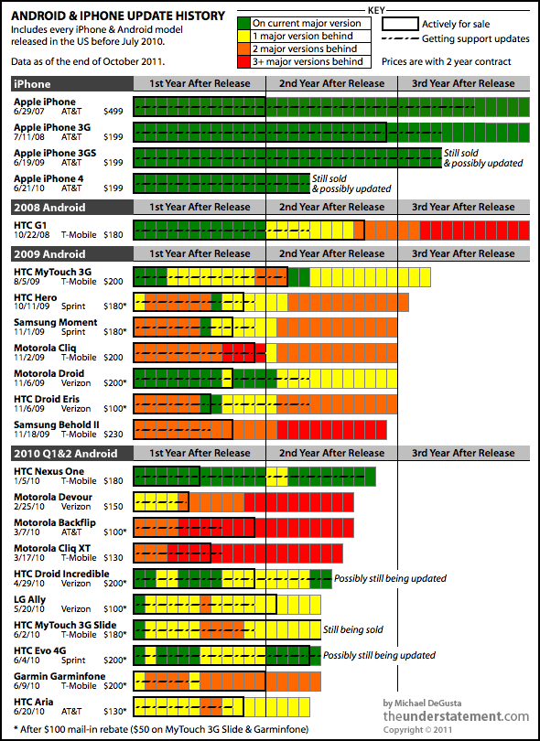

[Specifications List]

Specifications

* We want a View to use google maps to display bars on a map. The location of the bar should link (by touching) to a View which displays information about the bar. This information is extracted from the database which is created using a CMS.
* The basic application framework should generate basic frames in which the information should be displayed in. This refers to the mock-up.
* Here is a list of prioritising what is most important in relation to what the goal is:

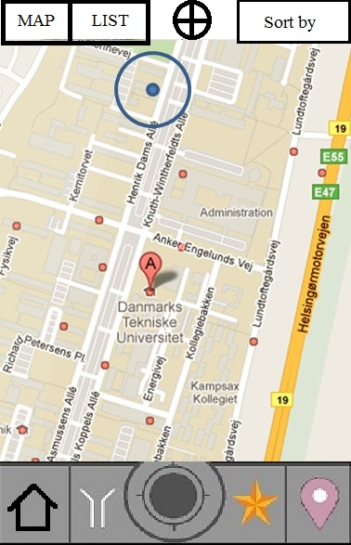

* 1. Map View
     + Locate user with the phones A-GPS
     + Map view displays bars within a defined radius of the user
     + Each bar is a link to a Information View (c), where the Bar information is displayed.
     + The header bar acts as a navigational menu to different views(Map/List) of the bars and is active within both views. It also contains a search field to enable the user to specify an address as a start point. To get back to the users current location we have a locate button which sets the users location as a start point.

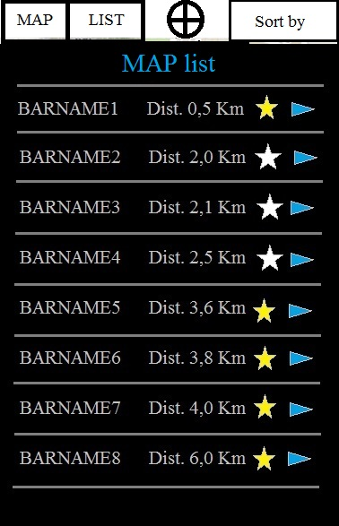

* 1. List View
     + List bar names in order of location (starting with the nearest one). This can be changed using the “sort by” button
     + Bars can be added and removed from the favorite View by touching the “favorite”/“star” button. This will change the appearance of the button, but not navigate the user anywhere.
     + Touching the bar name will navigate the user to the Information View.
  2. Information View
     + This View is bigger than the others, in the sense that it is three screens added together using the swipe function to browse through the “pages”.
     + The image shown in the center “page” will be the location of the bar as a static image of a map with a dot. This image will link to the map View.
       - Under the image there will be a navigation button which will switch to the Map View with directions.
       - There will be information about the address and opening hours here.
     + The Left “page” will display a list with prices and events.
     + The right “page” will display check in comments from users, who has checked in at this bar depending on Facebook. (Implementation depends on point f & g.)

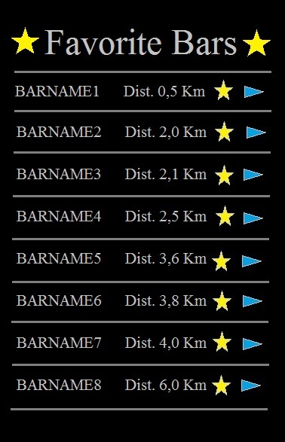

* 1. Favorite View
     + A list with favorite bars in the default order of distance from current location.
     + The user can touch the bar name and will be navigated to the Information View.(c)
     + The user can delete a favorite bar by touching the “star” button
  2. Filter/sort by View
     + 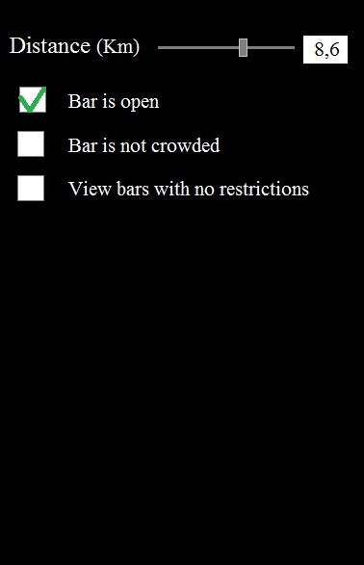Filter properties:
       - Distance in Km . This adjusted using a slide bar. And there is a counter to view the desired distance and to type in a desired distance if one prefer using this instead of the slidebar option.
       - Availability (function that checks the phone clock and searches if it is within the opening hours)
       - Restrictions (is it only for a group of students or all?)

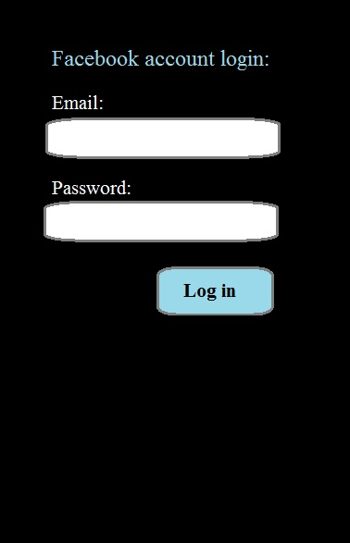

* 1. Facebook log in View
     + This will allow the user to enter Facebook log in information and thereby be navigated to the Bar update View(g). This feature will enable the user to check in (and write a facebook post),
  2. 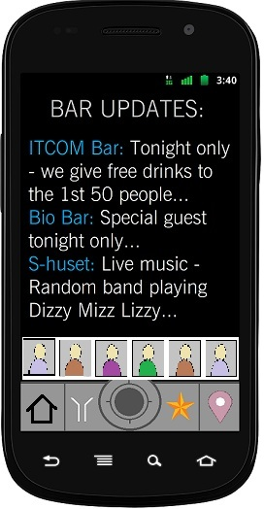Bar update View w/Facebook integration
     + Events posted on Facebook by bar employees/admins are displayed here together with posts by users who checked in.
  3. User Check in - Facebook Posts/Updates
     + The user can check in and write a message which will be posted on their own wall on Facebook and if they choose the right location within the check suggestions, it will also be posted as a check in, in the bar facebook page.

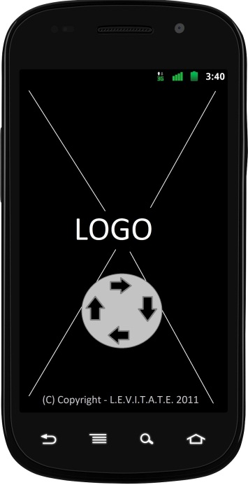

* 1. Splash screen View
     + Request user to login the first time application is launched, also explaining the added benefits of being logged in.

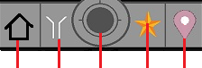

1 2 3 4 5

**The “main-menu” buttons:**

1. Home
   * This button will allow one to be navigated to the home screen also known as Bar Updates.
2. Filter
   * This button will show a new page with different criteria from which the map view should be displayed. This is a more specified version of button 3.
3. Show map with nearby student bars
   * This button will navigate to the “map view page”.
4. Favorite bars
   * This button will allow one to access a database with a list of one’s favorite bars. And the button will navigate the user to the “favorites page”
5. Check in
   * This button will allow one to check in at one’s current location.

Further definition of required data, API’s, things needed for programming the desired functionality of the app.

DATA list:

* **Bar information (CMS DB) (The DB is the most important issue here)**
* **Google Maps location DB**
* **Favorite bars (Internal phone DB)**
* **Facebook updates etc. (FB - DB)**
  + **Sending/receiving**
  + **Showing friends**
  + **Status/Location update**

1. Google Maps
   1. Map overlay (Plotting bars on map)
      1. Extraction of data from a DB
   2. Using “plot” to go to bar information's view page
   3. User location
      1. Bars within defined radius
2. Data for bars
   1. Add Bar to Database
      1. Name
      2. Location
3. Application framework
   1. Map View
   2. List View
      1. Sorting
      2. Favorites
   3. Bar information View
      1. General info (Description, Opening hours, prices etc.)
      2. Favorites
4. Structured and styled display of bar information in a Facebook Bar Page
   1. Page created in CMS implemented in the Facebook bar page by creating a facebook app
      1. The facebook app is basically an iFrame loaded in the specific bars Facebook Page.
5. Facebook implementation within Android App
   1. Display
      1. Events
      2. User Posts
   2. Add post
      1. User wall
      2. Bar wall
   3. Check-in to bar
6. Additional Application features

1. Appendix – Survey question 5
2. Appendix – Survey question 3
3. Appendix – Survey question 11
4. Appendix – Survey question 12
5. Appendix – Survey question 10
6. Appendix – Survey question 10
7. Included in appendix - *Android & iPhone update history*
8. “Rooting” - The act of gaining total access to the device boot-loader and the entire OS as a whole.